FortiGate Documentation — HQ (Forti 1) and BR (Forti 2)
1. Introduction
This document provides separate and detailed documentation for:
- FortiGate 1 (HQ)
- FortiGate 2 (BR)
Both devices use the same VLAN structure, firewall policies, and security profiles to maintain standardization and consistent security across sites.
2. FortiGate 1 — HQ Configuration
2.1 VLANs (HQ)
- IT – VLAN 10 – 192.168.10.0/24
- HR – VLAN 20 – 192.168.20.0/24
- Finance – VLAN 30 – 192.168.30.0/24
- Management – VLAN 40 – 192.168.40.0/24
- Sales – VLAN 50 – 192.168.50.0/24
- Servers – VLAN 60 – 192.168.60.0/24
2.2 Firewall Policies (HQ)
Firewall Policies Implemented
The following firewall policies were created and configured on this FortiGate device.
Each policy includes a screenshot for reference, showing the exact configuration applied on the firewall.

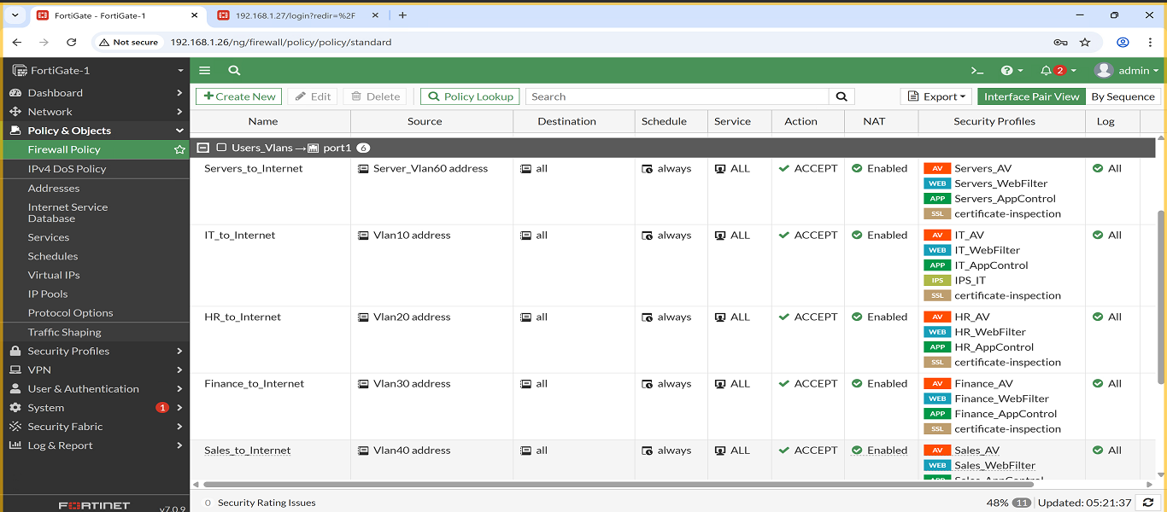
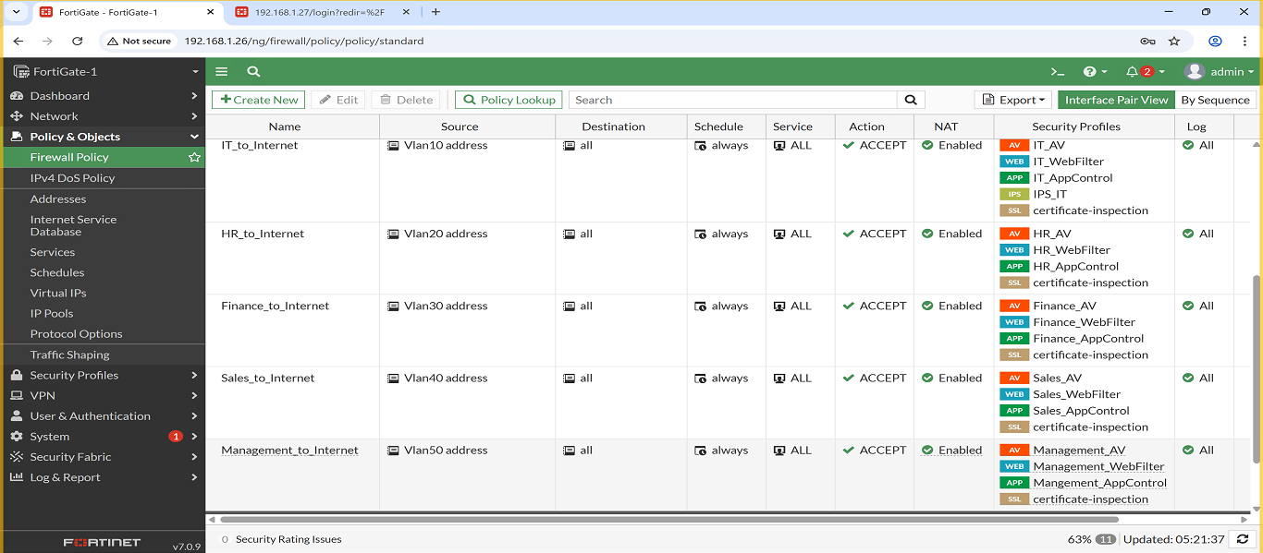

1. Policy: IT → Internet
- Description: Allows IT VLAN access to the internet, and applies the following security profiles: Web Filter, Antivirus, Application Control and IPS.
- Screenshot:
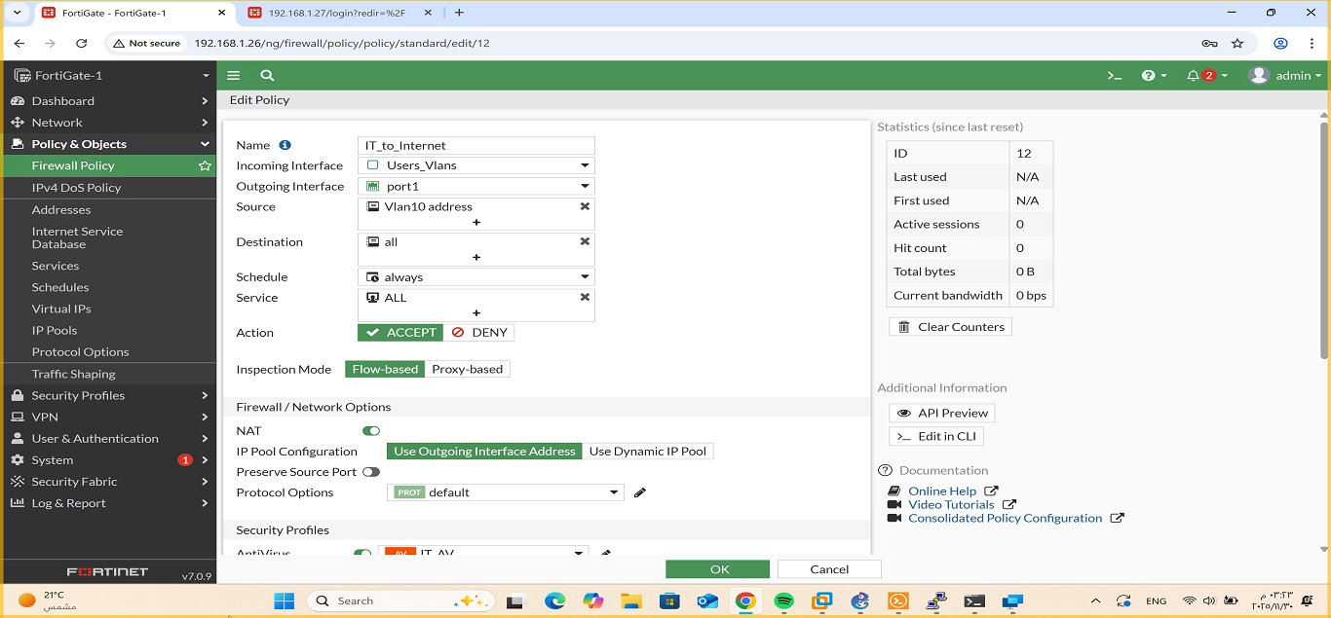
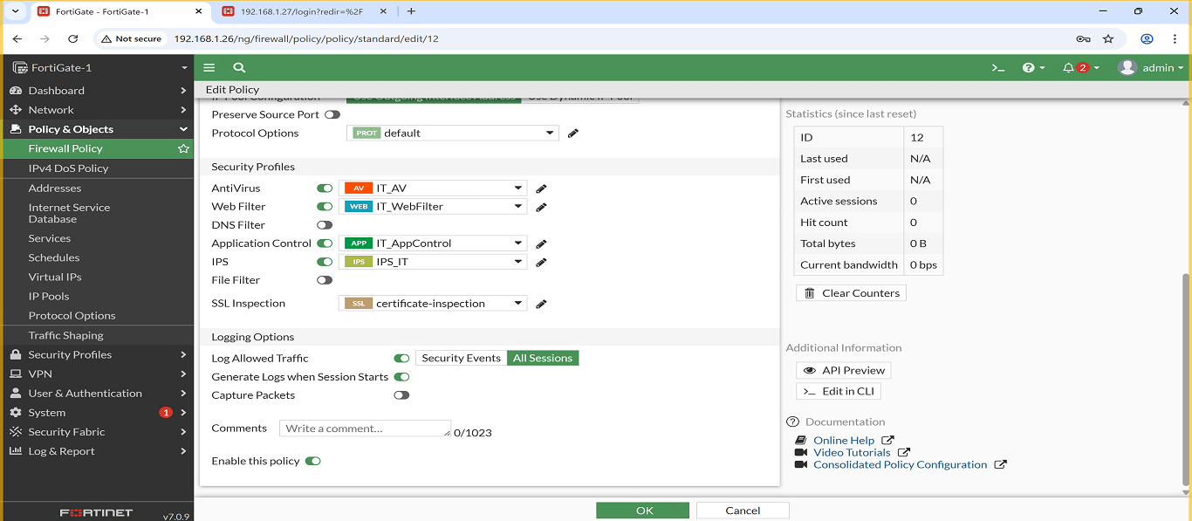

2. Policy: HR → Internet
- Description: Allows HR VLAN access to the internet, and applies the following security profiles: Web Filter, Antivirus and Application Control.
- Screenshot:
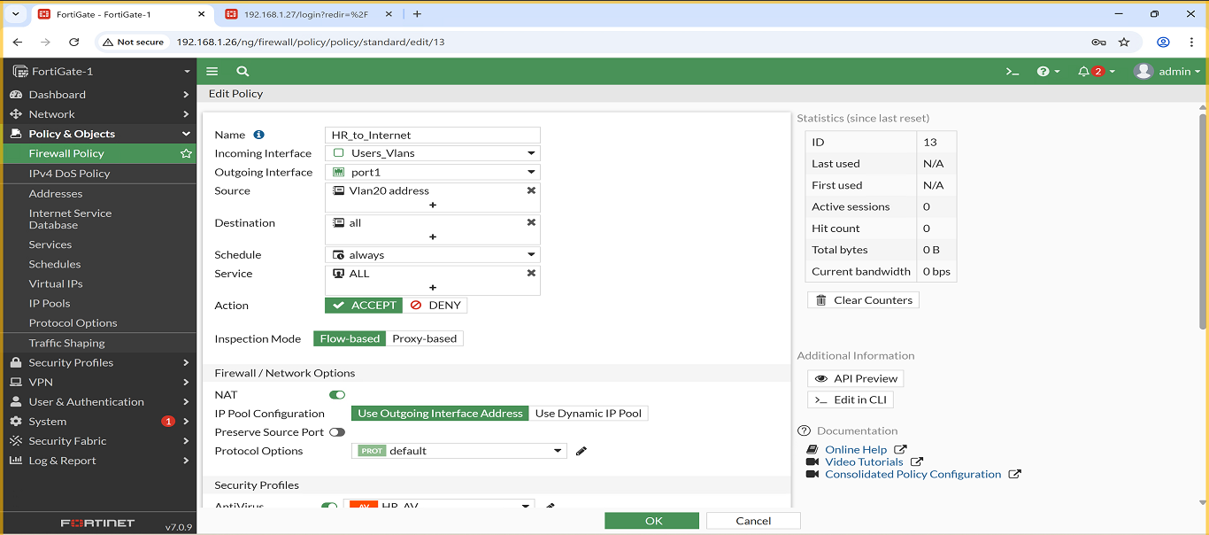
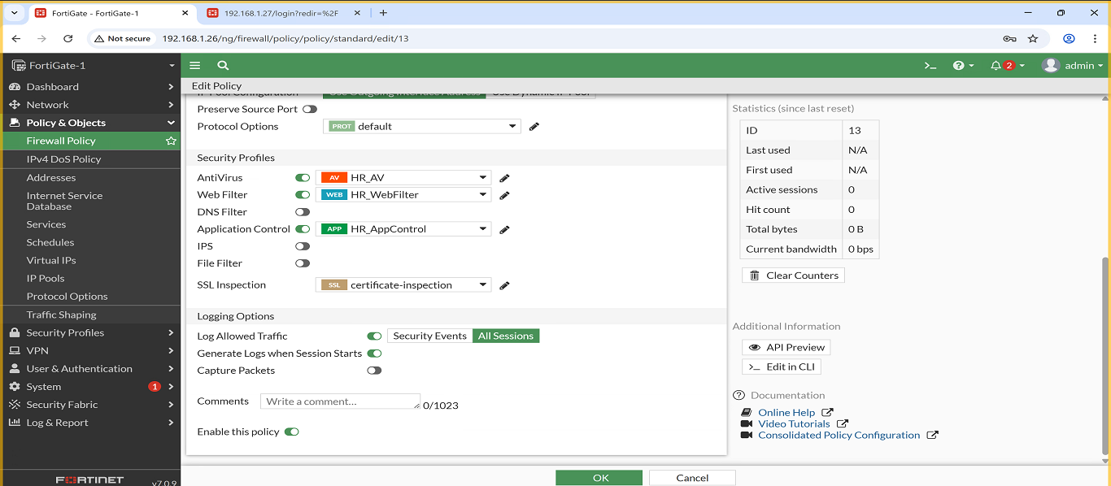
3. Policy: Finance → Internet
Description: Allows Finance VLAN access to the internet, and applies the following security profiles: Web Filter, Antivirus and Application Control.
- Screenshot:
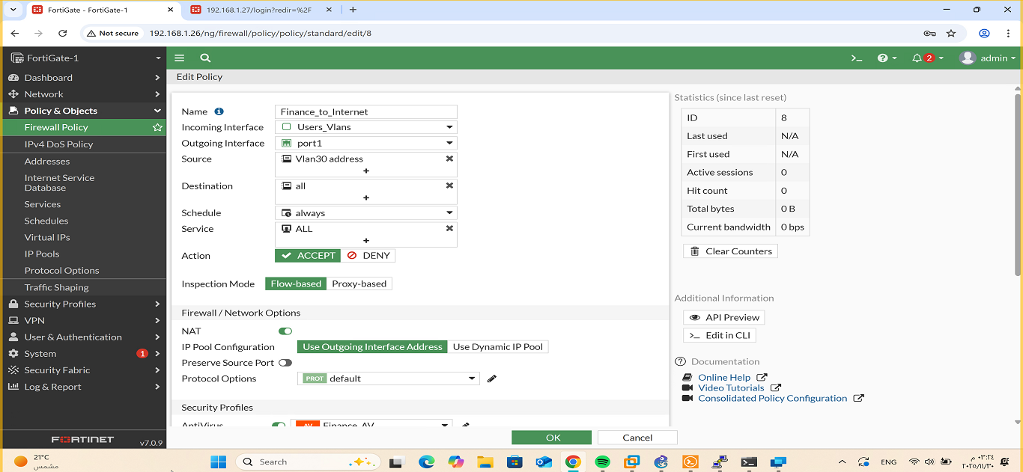
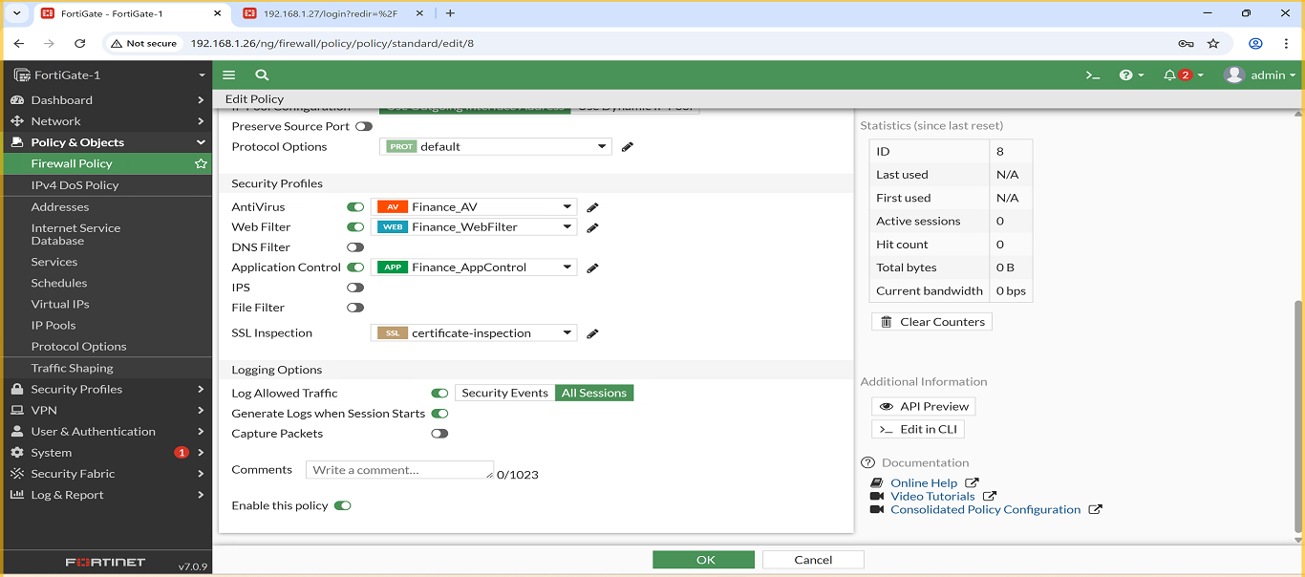
4. Policy: Management → Internet
- Description: Allows Management VLAN access to the internet, and applies the following security profiles: Web Filter, Antivirus and Application Control.
- Screenshot:
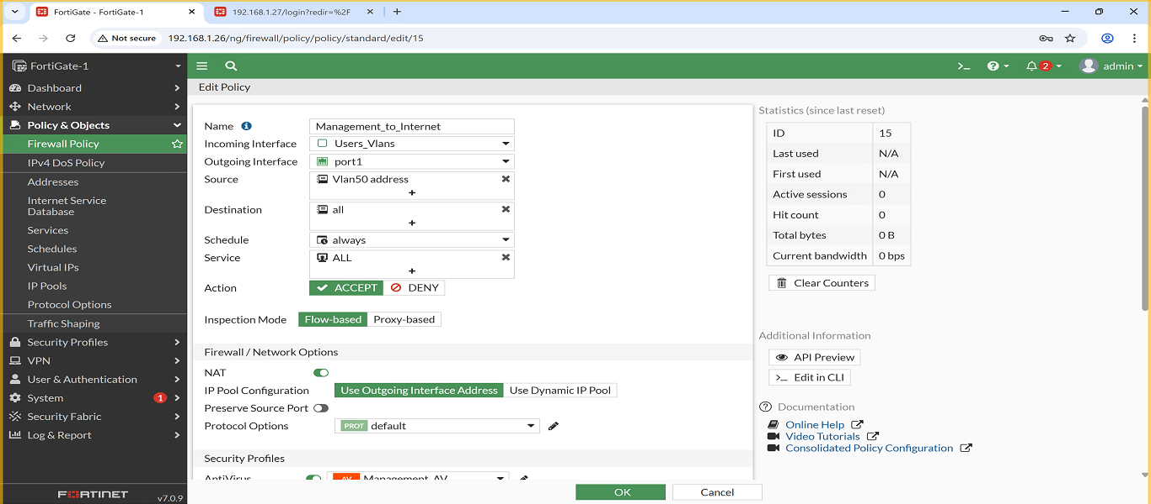
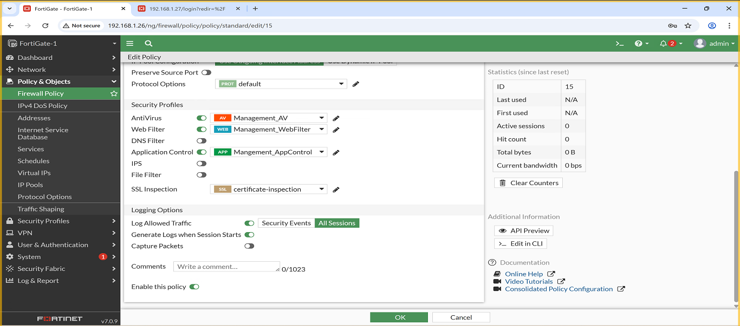
5. Policy: Sales → Internet
- Description: Allows Sales VLAN access to the internet, and applies the following security profiles: Web Filter, Antivirus and Application Control.
- Screenshot:
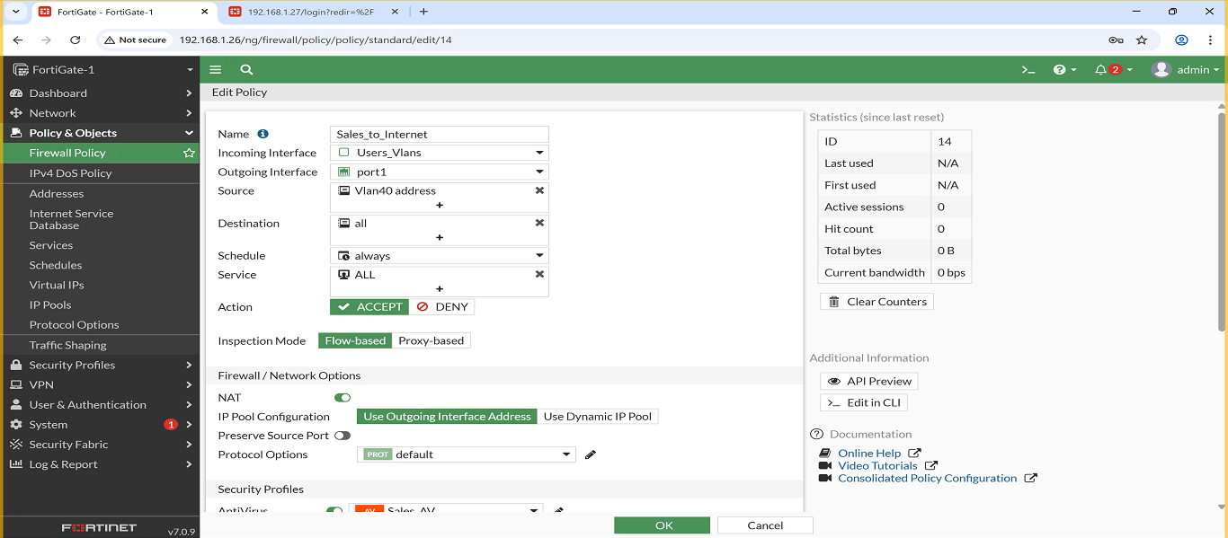
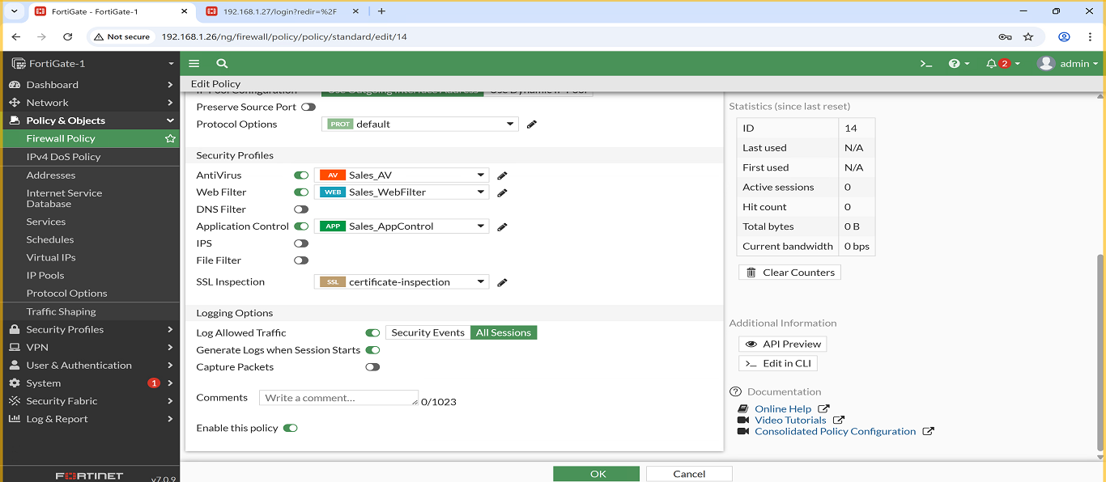
6. Policy: Servers → Internet
- Description: Allows Servers VLAN access to the internet, and applies the following security profiles: Web Filter, Antivirus and Application Control.
- Screenshot:

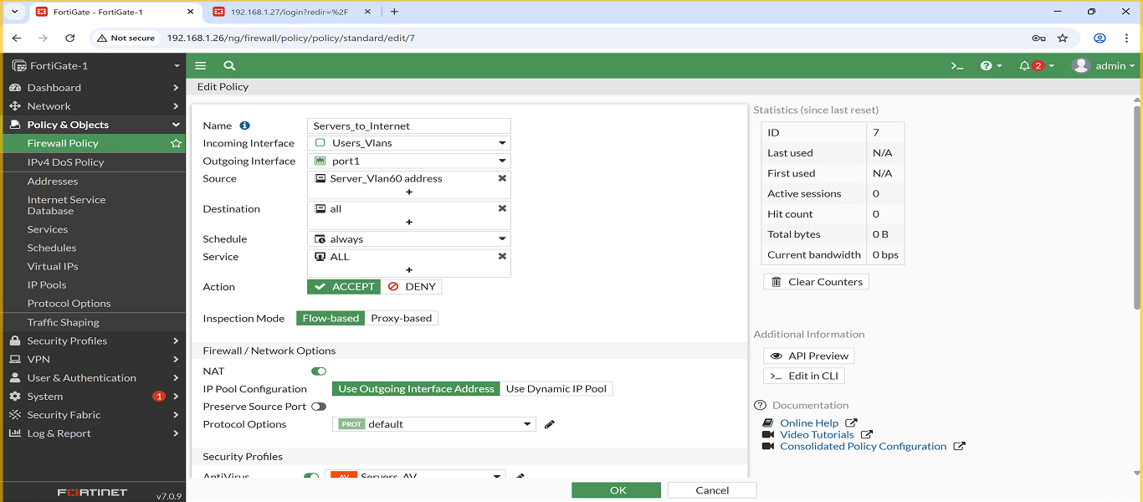
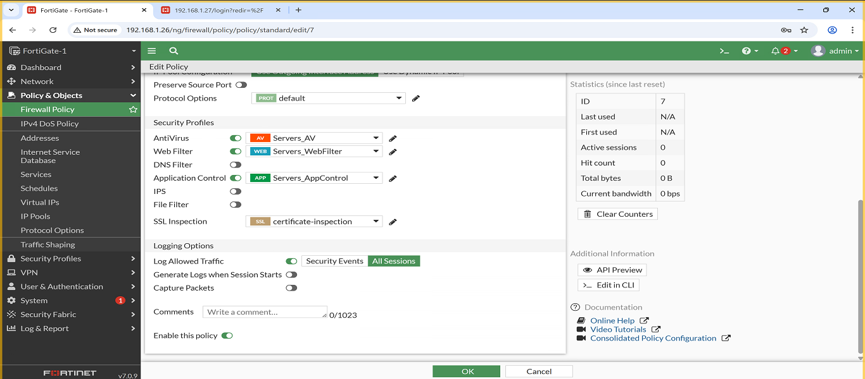
2.3 Security Profiles (HQ)

1.Web Filter:
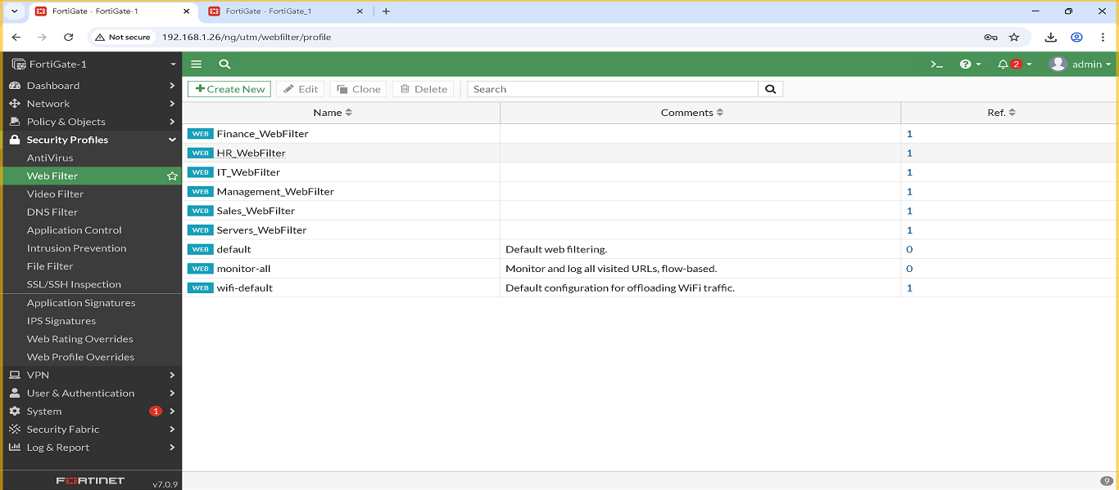
2.AntiVirus:
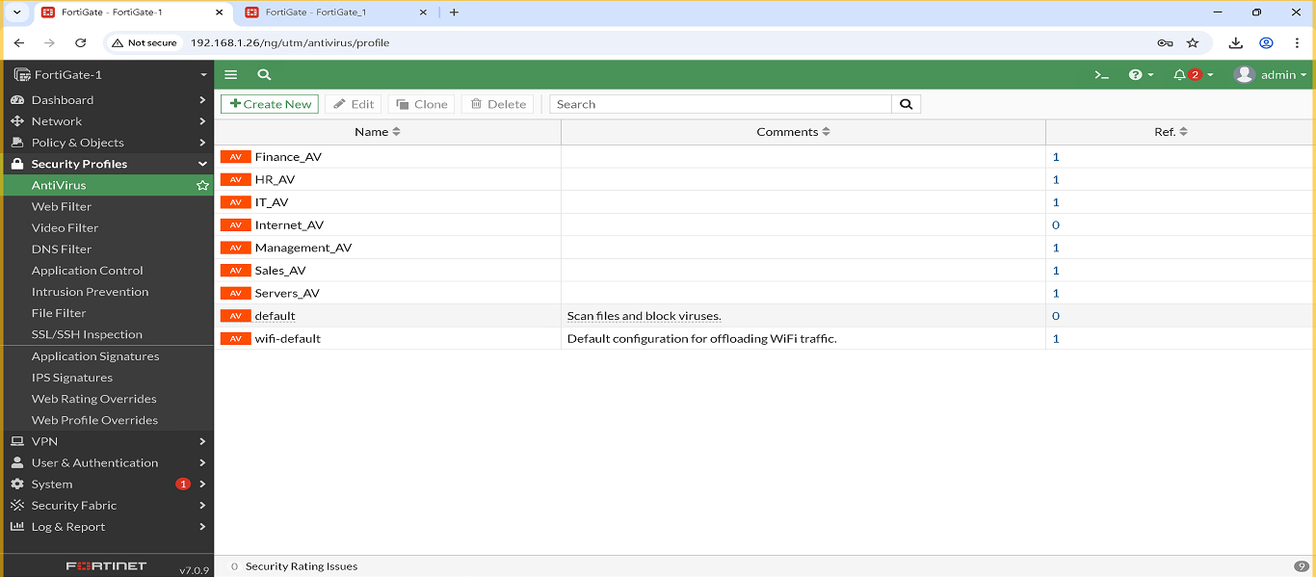

3.Application Control:
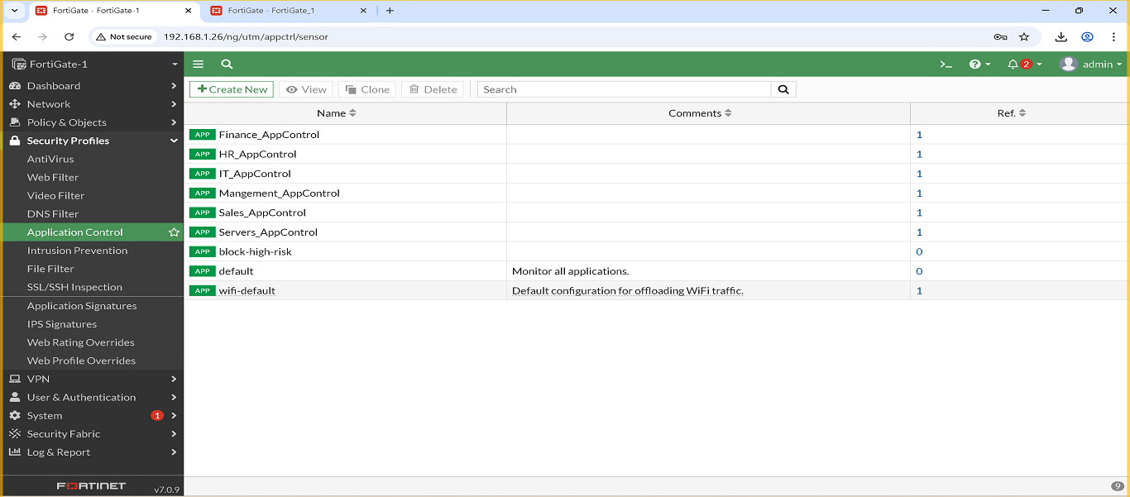
IT VLAN – Security Profiles
Three security profiles were created and assigned to the IT VLAN to enhance security and control user traffic:
- IT_WebFilter
  - Allowed Websites: github.com , microsoft.com
  - Blocked Websites: pornhub.com , facebook.com
  - Screenshot:
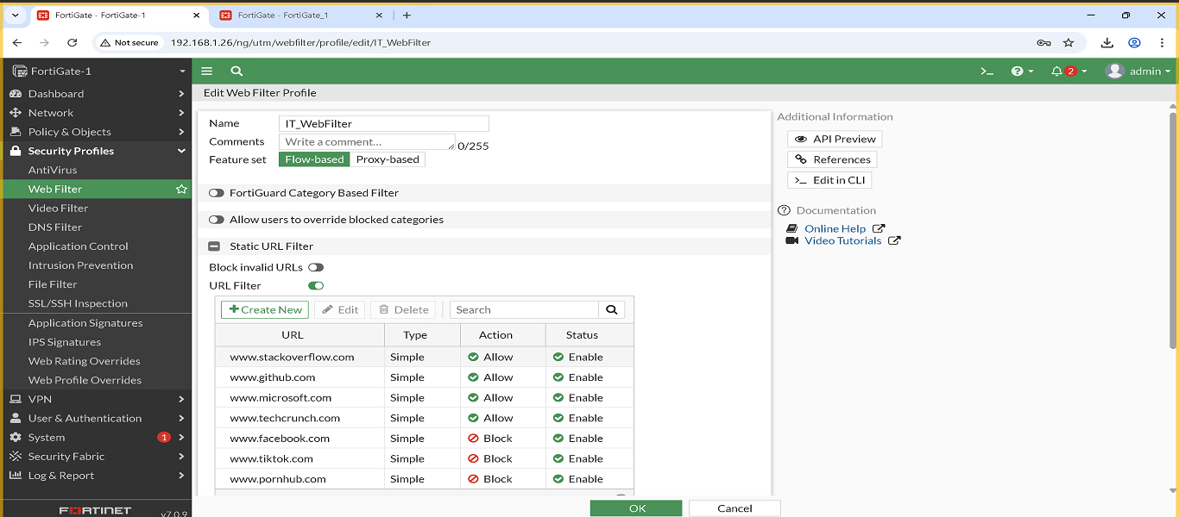
- IT_Antivirus
  - This AntiVirus profile is configured in Block mode with flow-based scanning, and I enabled inspection for the following protocols: HTTP, SMTP, POP3, IMAP, FTP, and CIFS. Mobile malware protection and Quarantine are also enabled to isolate any detected threats.
  - Screenshot:
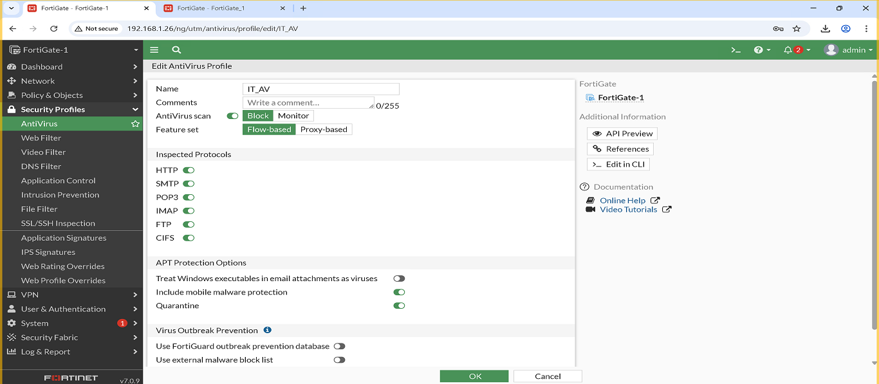
- IT_AppControl
  - I configured rules to allow certain applications and block unnecessary ones, along with custom Application Filters for the IT VLAN to manage traffic.
  - Screenshot:
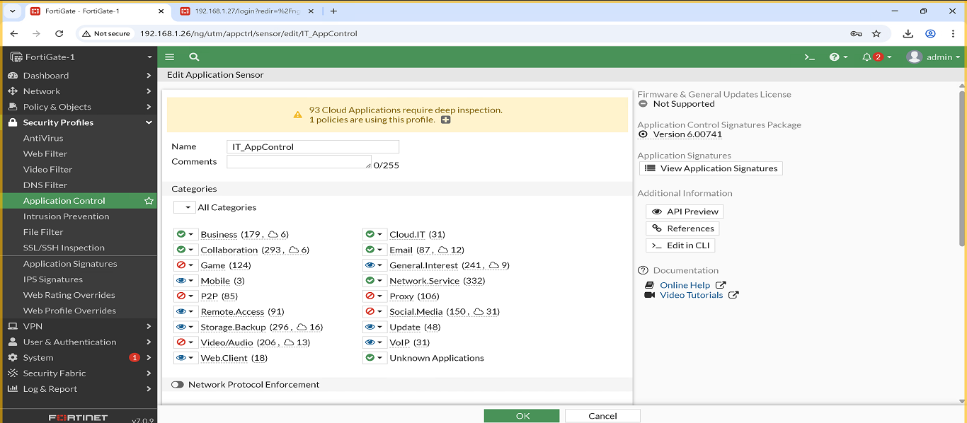
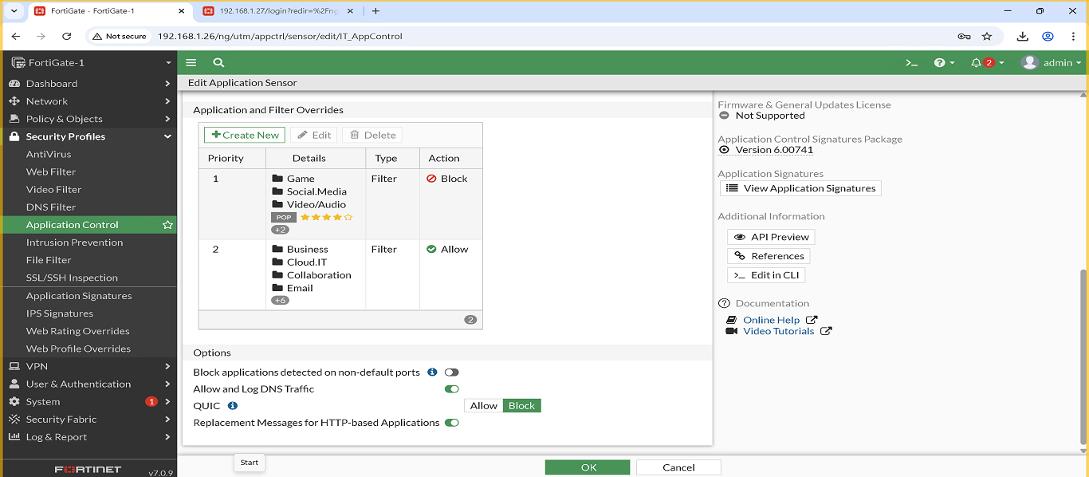
4.Intrusion Prevention:
- An Intrusion Prevention Security Profile named IPS_IT was created, and a set of IPS signatures was added with the default action and packet logging disabled. The Block option was also enabled to scan and block outgoing connections to Botnet sites.
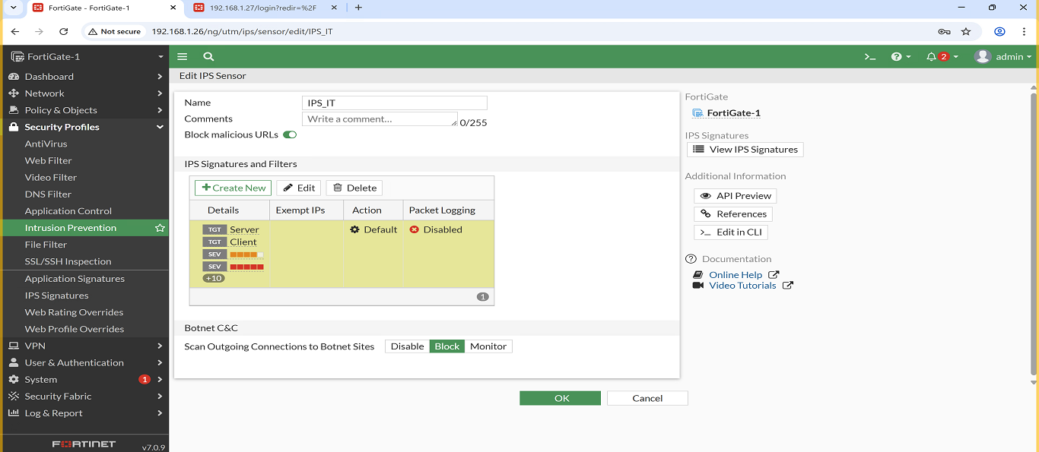
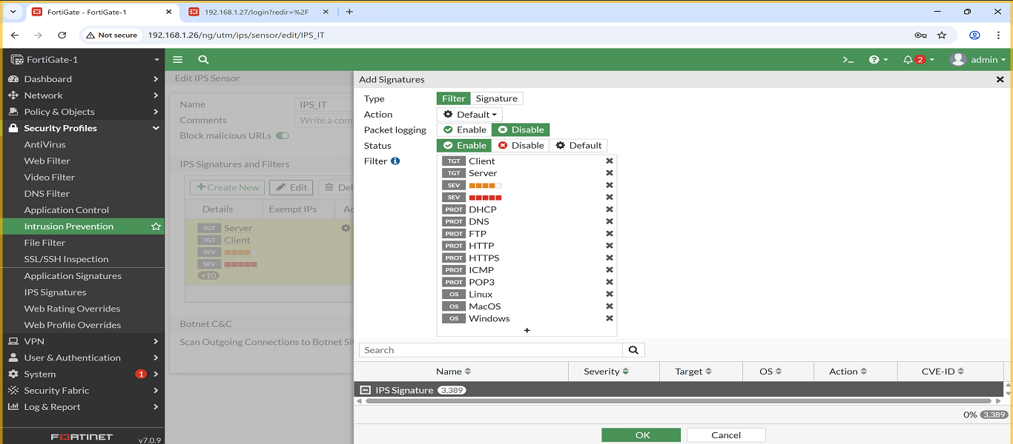

* I intended to apply the Intrusion Prevention Security Profile to the remaining VLANs, but the system displayed an error indicating that the maximum number of entries had been reached.
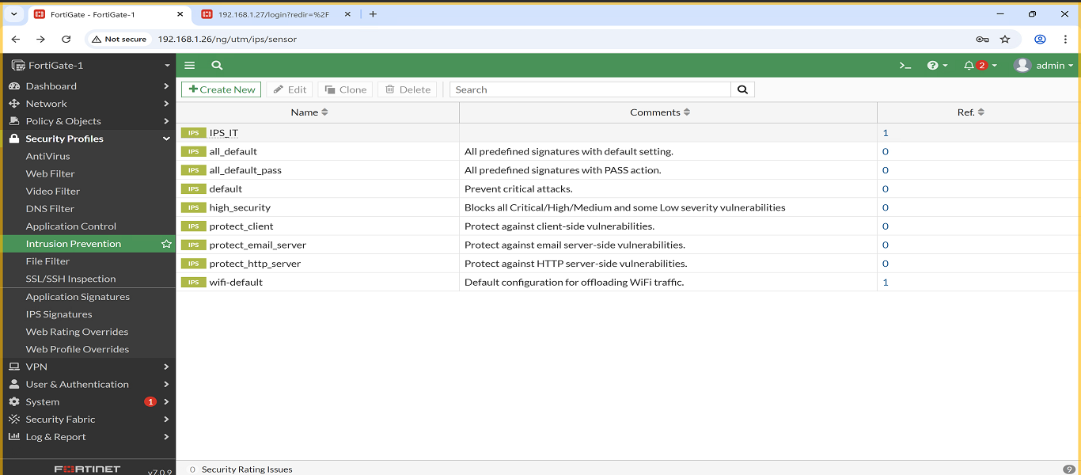
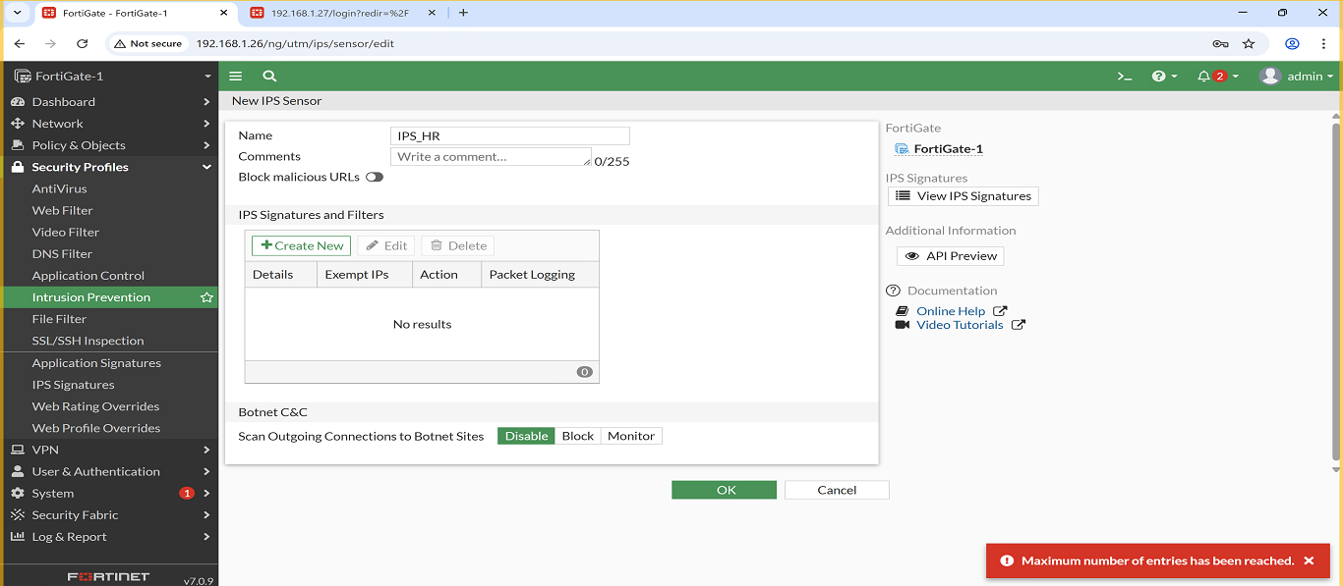

HR VLAN – Security Profiles
Three profiles were applied to ensure HR browsing is monitored and controlled:
- HR_WebFilter
  - Allowed Websites: linkedin.com , zoom.com
  - Blocked Websites: pornhub.com , reddit.com
  - Screenshot:
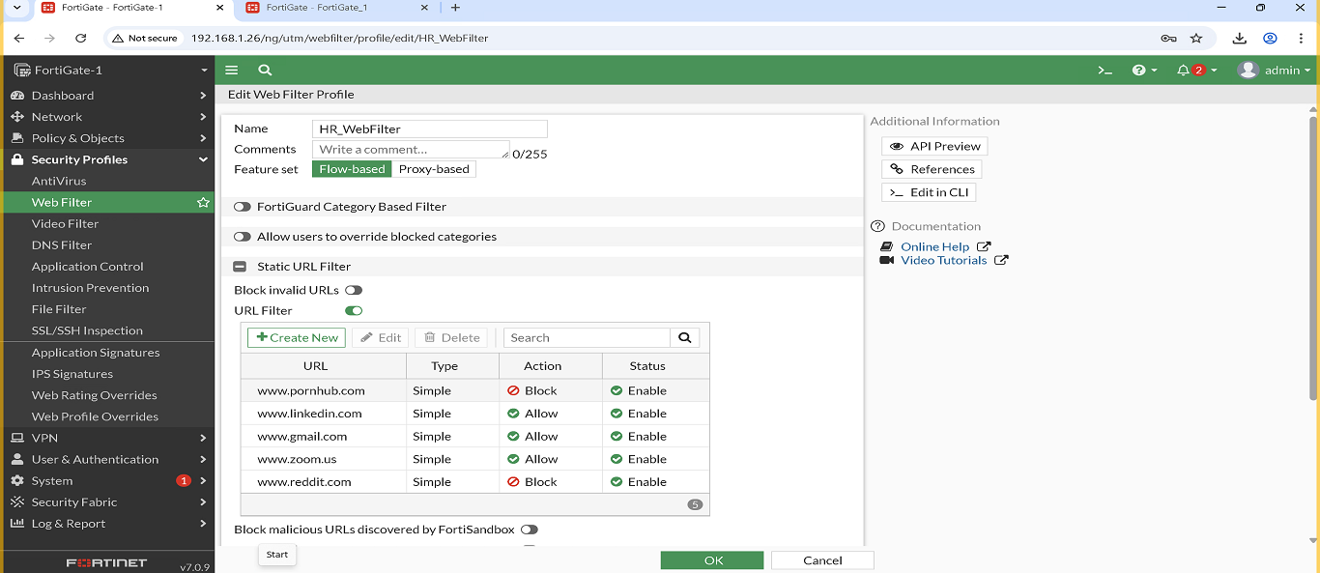
- HR_Antivirus
  - This AntiVirus profile is configured in Block mode with flow-based scanning, and I enabled inspection for the following protocols: HTTP, SMTP, POP3, IMAP, FTP, and CIFS. Mobile malware protection and Quarantine are also enabled to isolate any detected threats.

  - Screenshot:
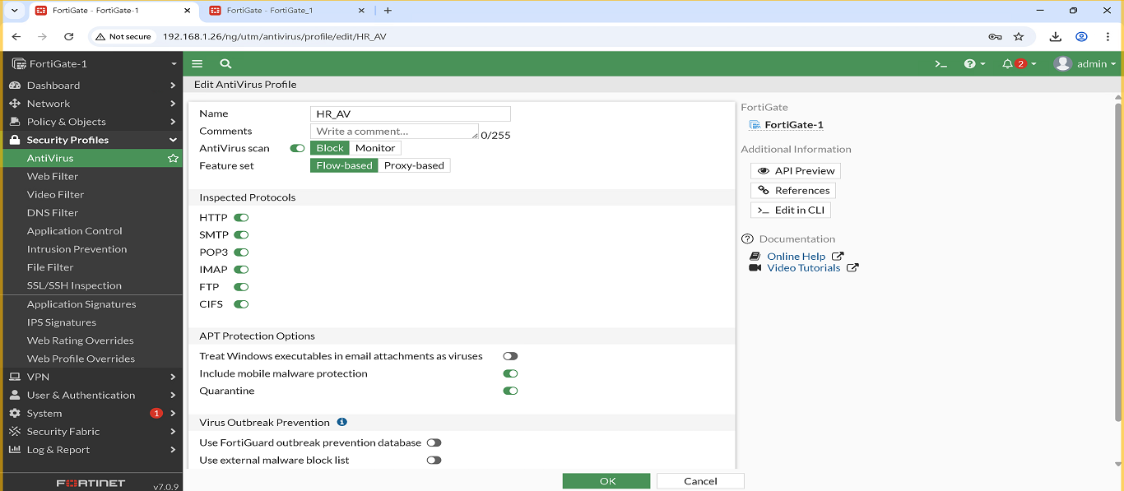
- HR_AppControl
  - I configured rules to allow certain applications and block unnecessary ones, along with custom Application Filters for the HR VLAN to manage traffic.
  - Screenshot:
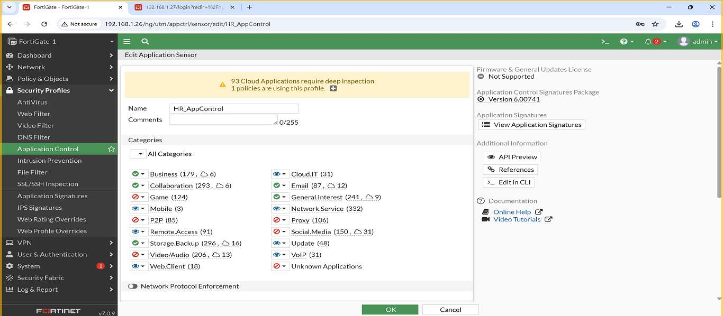
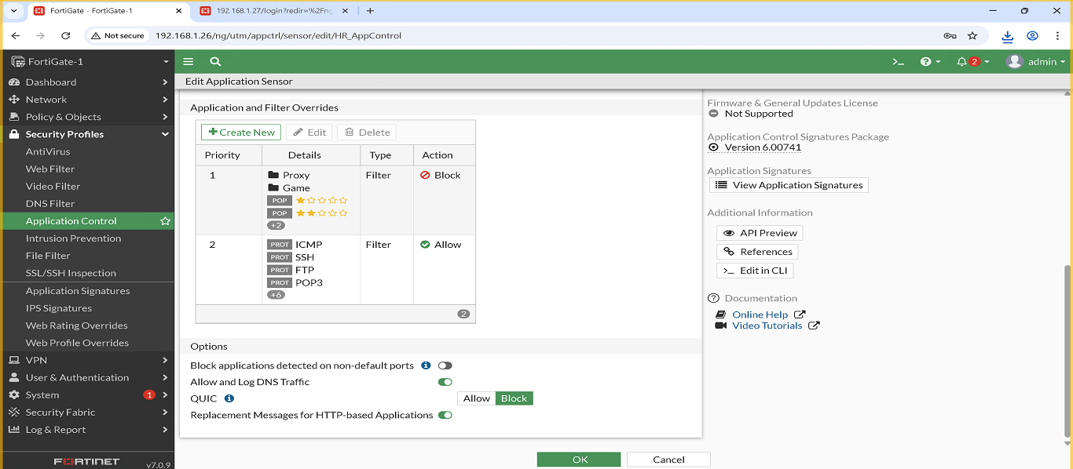

Finance VLAN – Security Profiles
- Finance_WebFilter
  - Allowed Websites: investopedia.com , microsoft.com
  - Blocked Websites: facebook.com , tiktok.com
  - Screenshot:
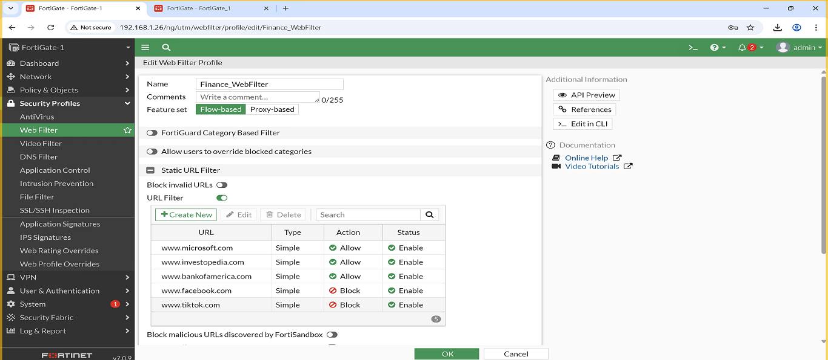
- Finance_Antivirus
  - This AntiVirus profile is configured in Block mode with flow-based scanning, and I enabled inspection for the following protocols: HTTP, SMTP, POP3, IMAP, FTP, and CIFS. Mobile malware protection and Quarantine are also enabled to isolate any detected threats.
  - Screenshot:
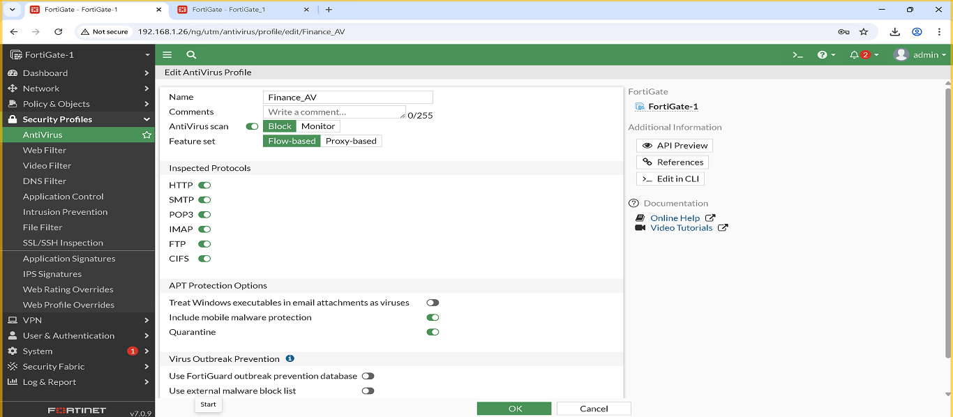
- Finance_AppControl
  - I configured rules to allow certain applications and block unnecessary ones, along with custom Application Filters for the Finance VLAN to manage traffic.
  - Screenshot:
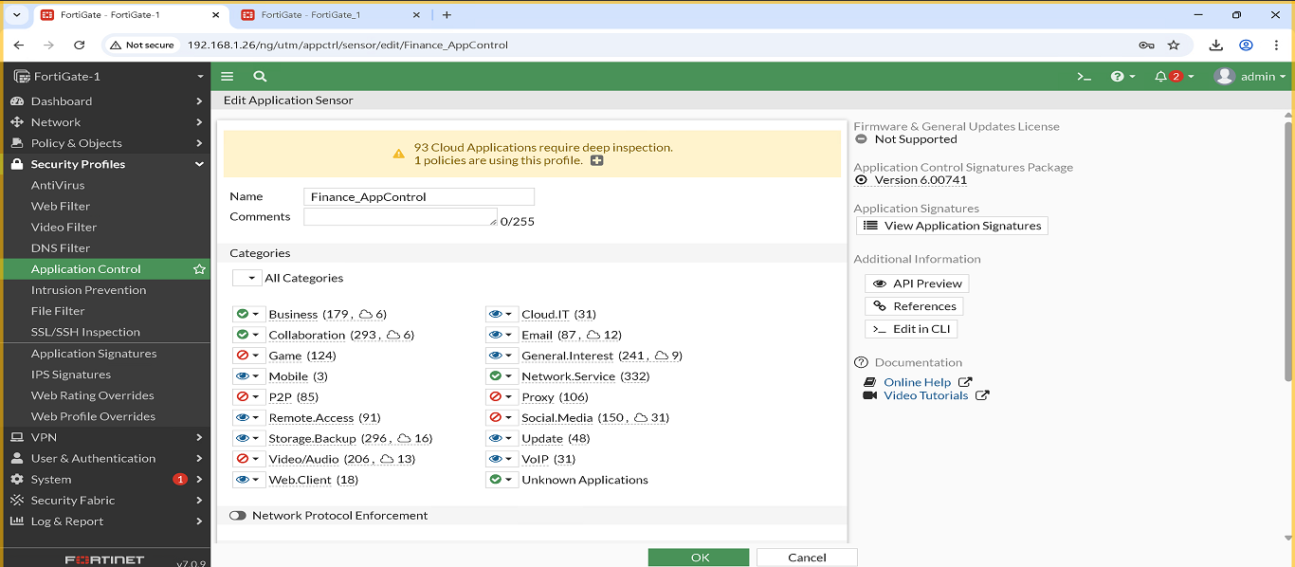
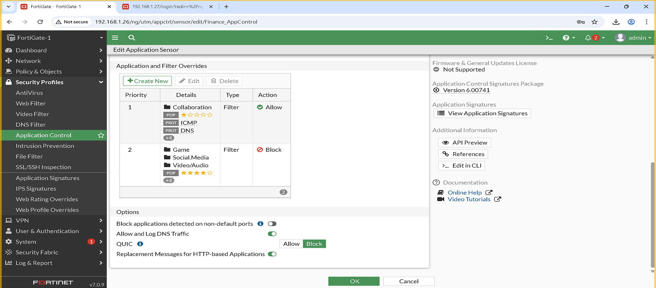

Sales VLAN – Security Profiles
Three security profiles were created and applied to the Sales VLAN to ensure controlled and secure web access:
- Sales_WebFilter
  - Allowed Websites: shopify.com , salesforce.com
  - Blocked Websites: youtube.com , tiktok.com
  - Screenshot:
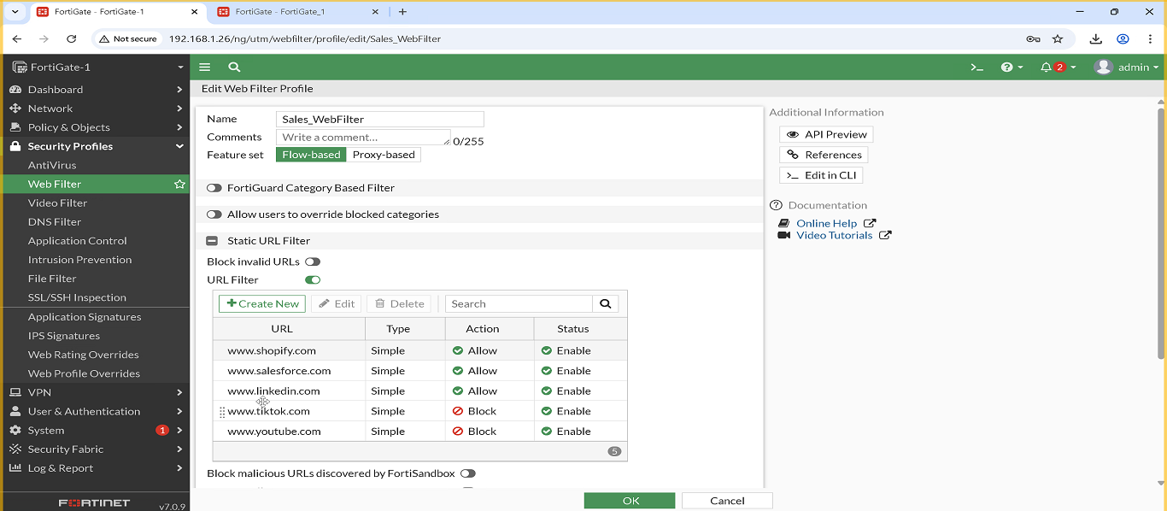
2. Sales_Antivirus
  - This AntiVirus profile is configured in Block mode with flow-based scanning, and I enabled inspection for the following protocols: HTTP, SMTP, POP3, IMAP, FTP, and CIFS. Mobile malware protection and Quarantine are also enabled to isolate any detected threats.
  - Screenshot:
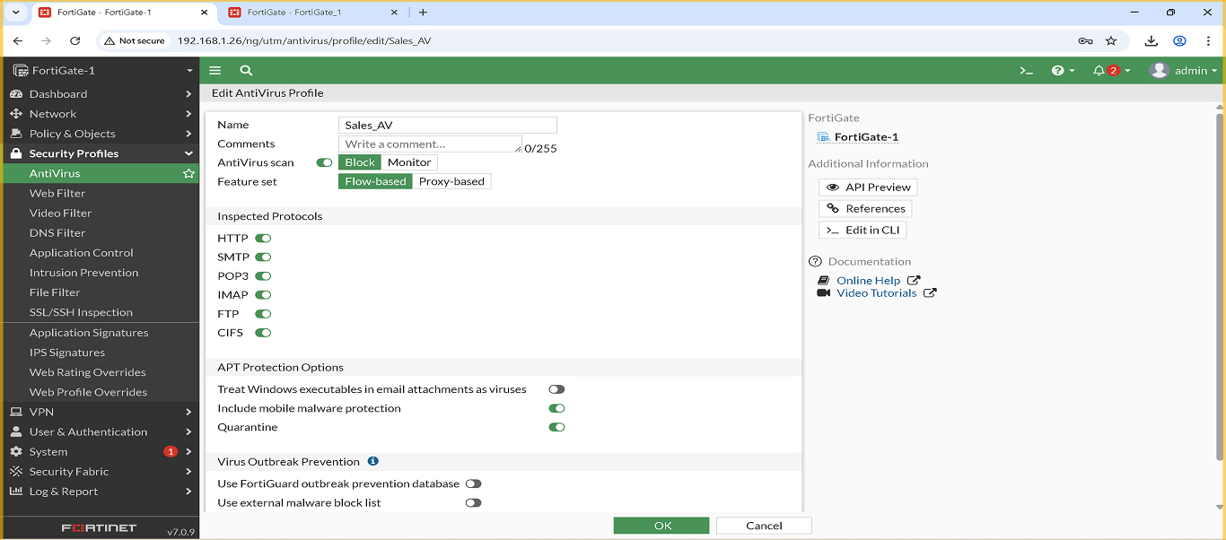
- Sales_AppControl
  - I configured rules to allow certain applications and block unnecessary ones, along with custom Application Filters for the Sales VLAN to manage traffic.
  - Screenshot:
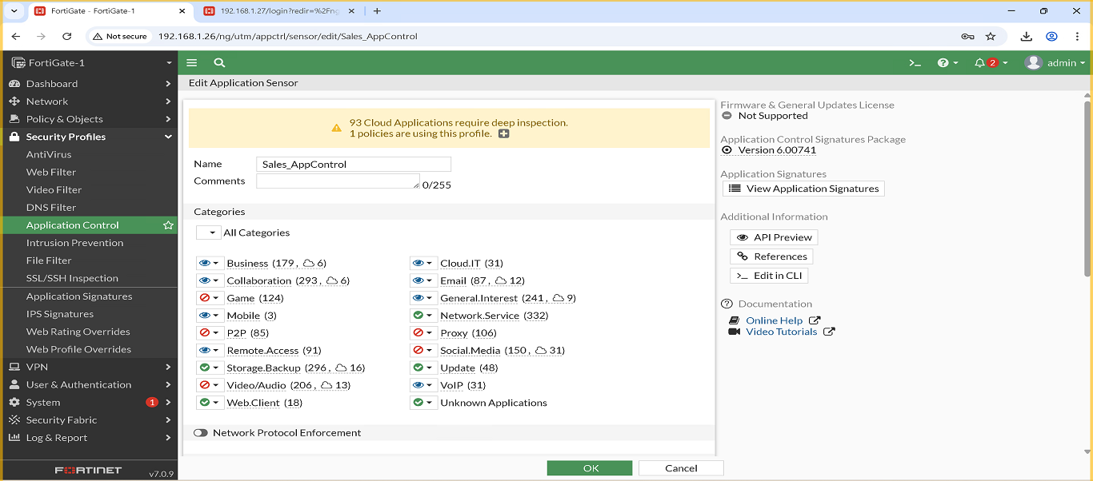
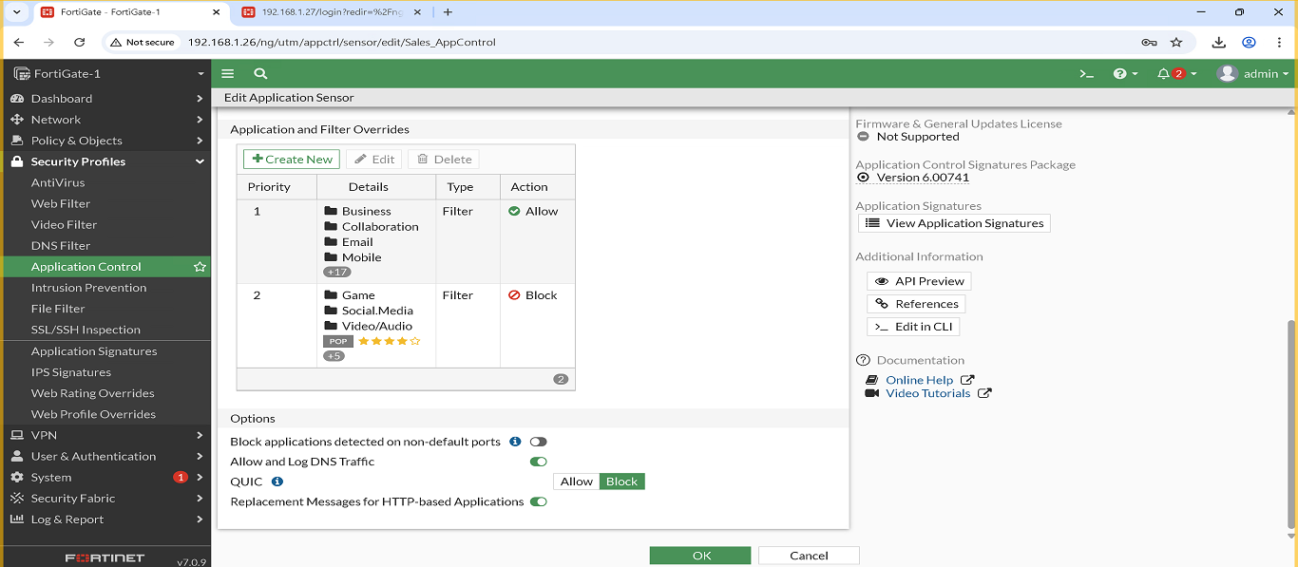

Management VLAN – Security Profiles
Three high-level security profiles were configured for the Management VLAN to ensure safe and controlled access:
- Management_WebFilter
  - Allowed Websites: microsoft.com , linkedin.com
  - Blocked Websites: pornhub.com , facebook.com
  - Screenshot:
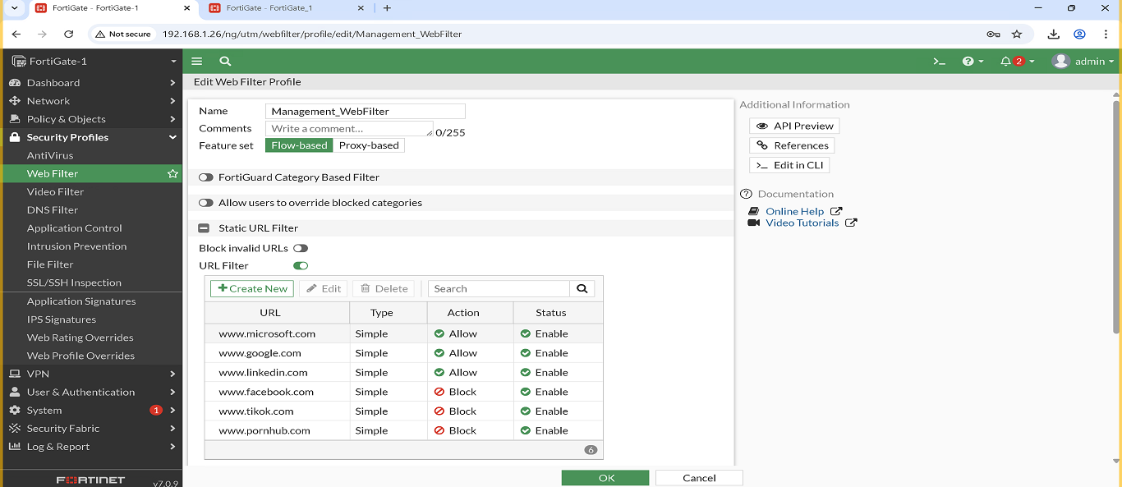
- Management_Antivirus
  - This AntiVirus profile is configured in Block mode with flow-based scanning, and I enabled inspection for the following protocols: HTTP, SMTP, POP3, IMAP, FTP, and CIFS. Mobile malware protection and Quarantine are also enabled to isolate any detected threats.
  - Screenshot:
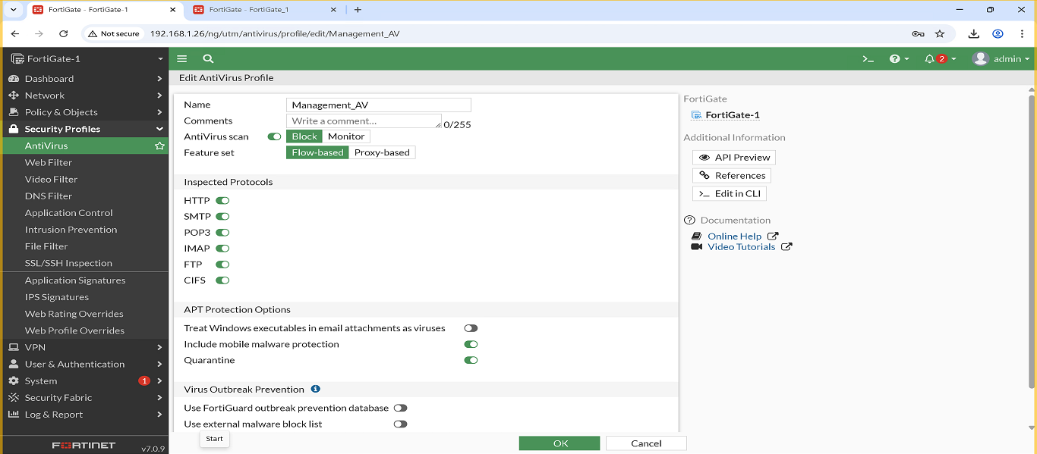
- Management_AppControl
  - I configured rules to allow certain applications and block unnecessary ones, along with custom Application Filters for the Management VLAN to manage traffic.
  - Screenshot:
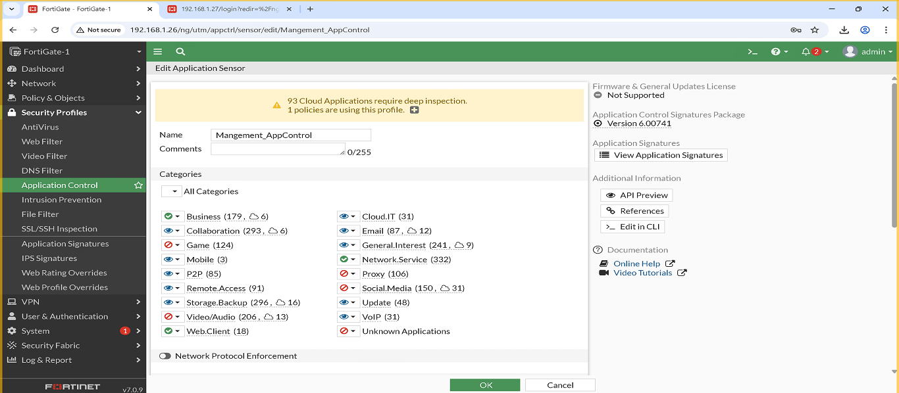
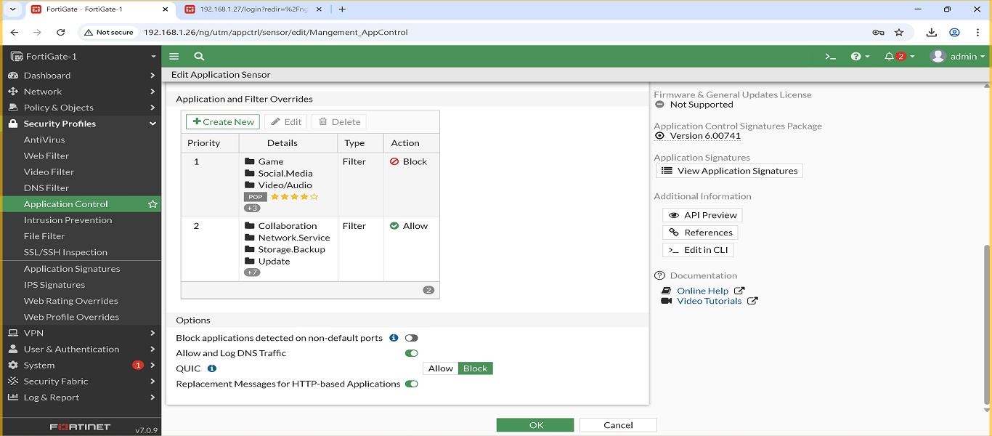

Servers VLAN – Security Profiles
Three security profiles were applied to the Servers VLAN to protect server traffic and maintain stable operations:
- Servers_WebFilter
  - Allowed Websites: github.com , microsoft.com
  - Blocked Websites: tiktok.com , youtube.com
  - Screenshot:
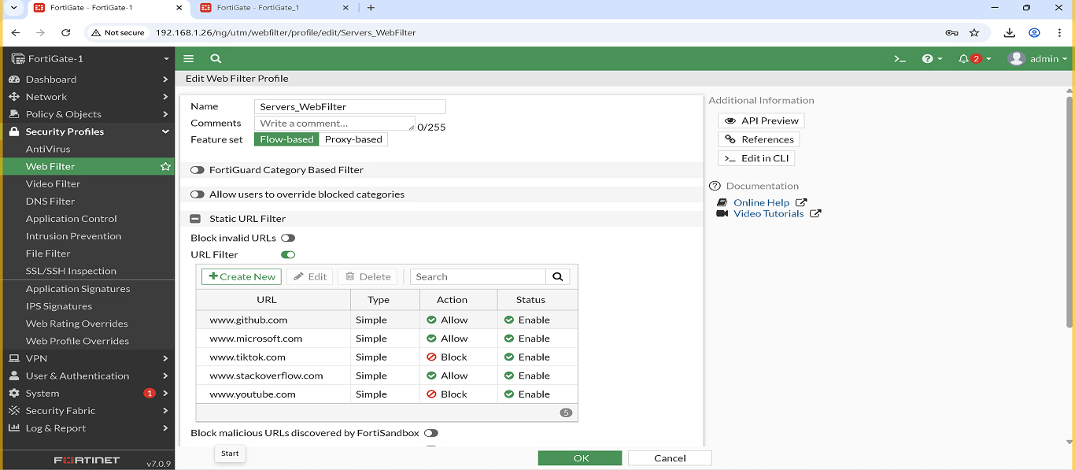
- Servers_Antivirus
  - This AntiVirus profile is configured in Block mode with flow-based scanning, and I enabled inspection for the following protocols: HTTP, FTP, and CIFS. Mobile malware protection and Quarantine are also enabled to isolate any detected threats.
  - Screenshot:
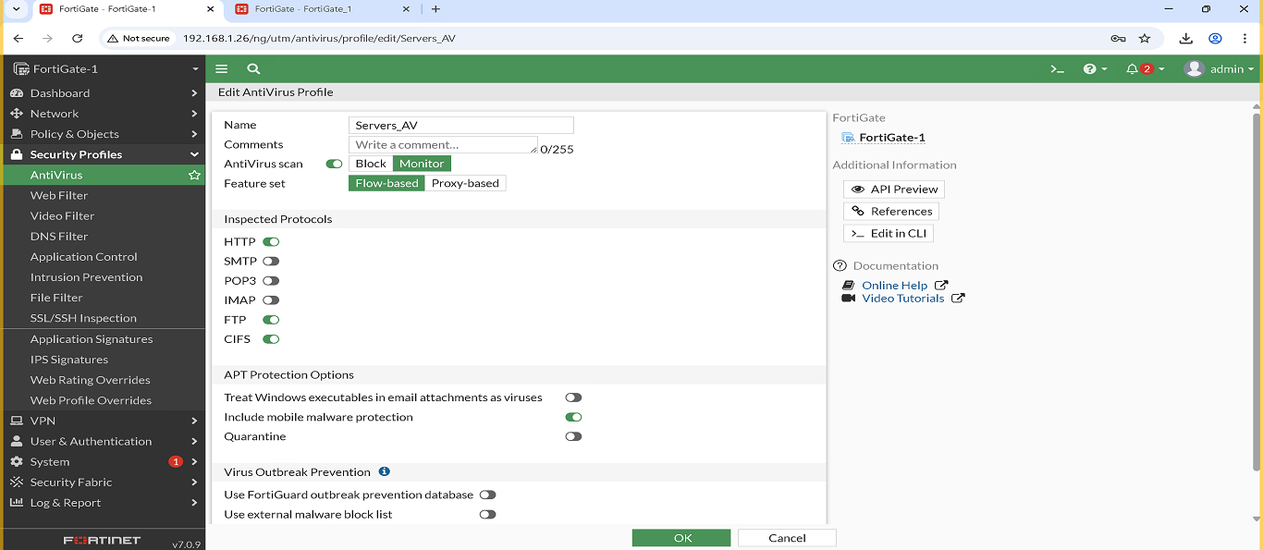
- Servers_AppControl
  - I configured rules to allow certain applications and block unnecessary ones, along with custom Application Filters for the Servers VLAN to manage traffic.
  - Screenshot:
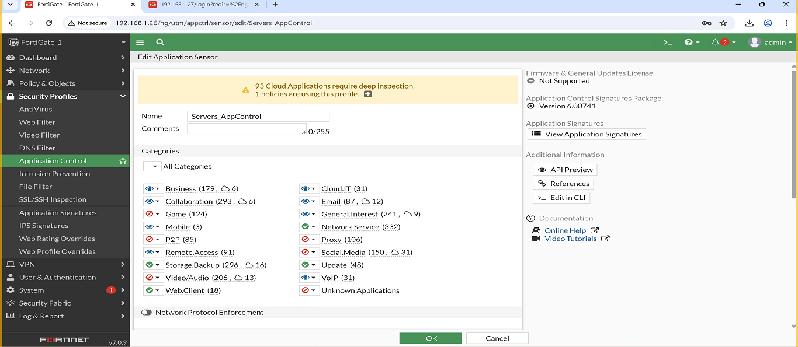
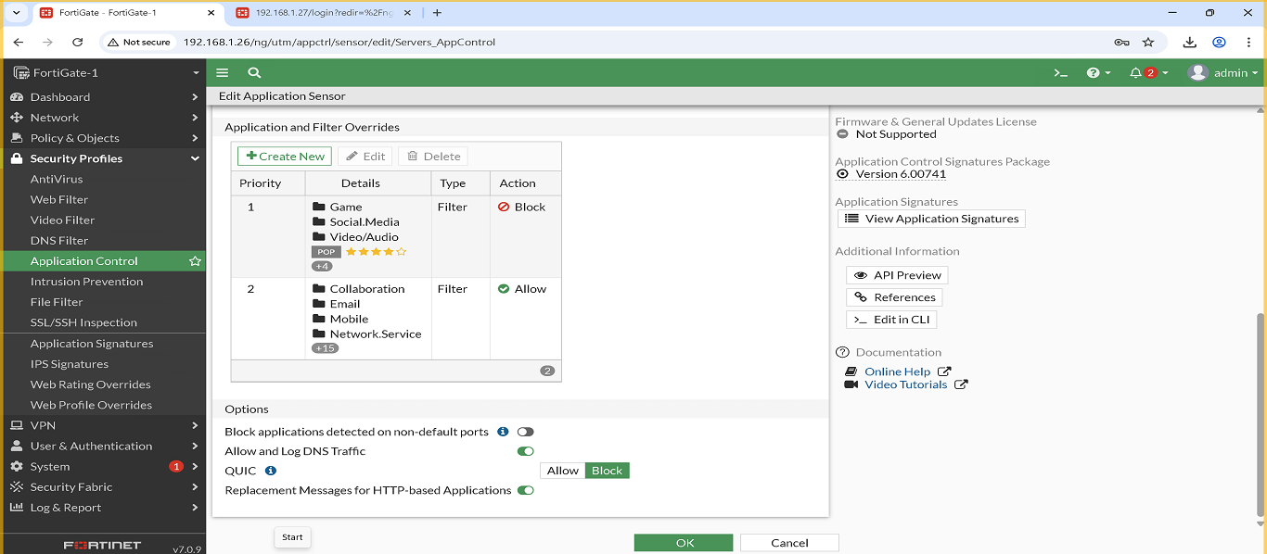

3. FortiGate 2 — Branch (BR) Configuration
3.1 VLANs (BR)
Same VLAN structure as HQ:
- IT – VLAN 10 – 172.16.10.0/24
- HR – VLAN 20 – 172.16.20.0/24
- Finance – VLAN 30 – 172.16.30.0/24
- Management – VLAN 40 – 172.16.40.0/24
- Sales – VLAN 50 – 172.16.50.0/24
- Servers – VLAN 60 – 172.16.60.0/24
3.2 Firewall Policies (BR)
Firewall Policies Implemented
The following firewall policies were created and configured on this FortiGate device.
Each policy includes a screenshot for reference, showing the exact configuration applied on the firewall.
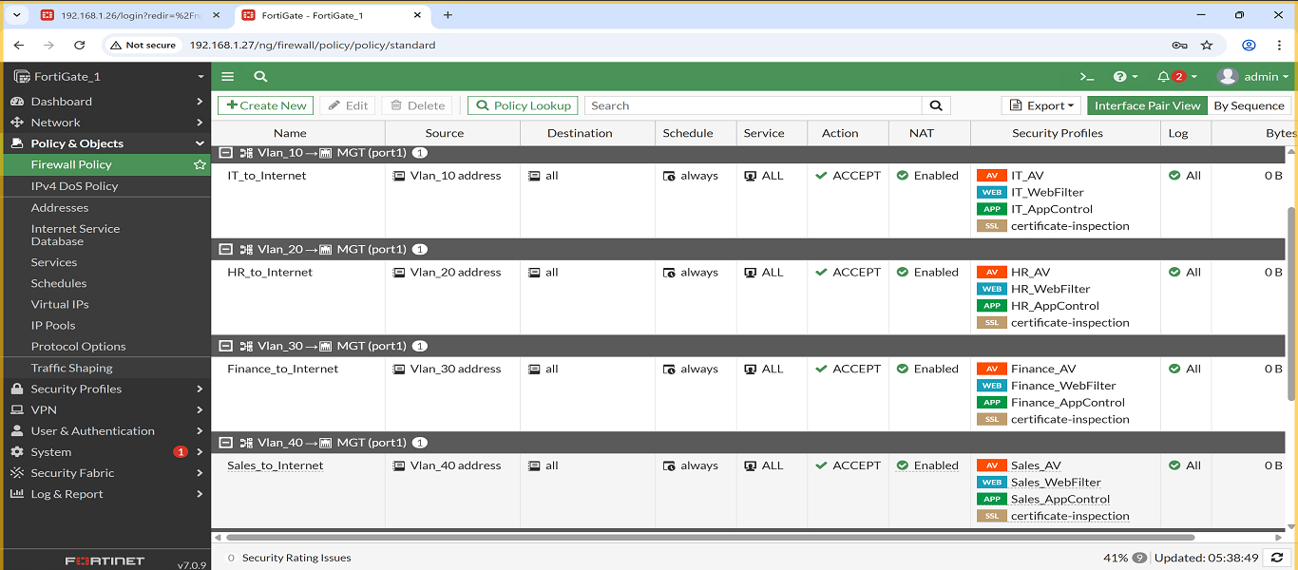
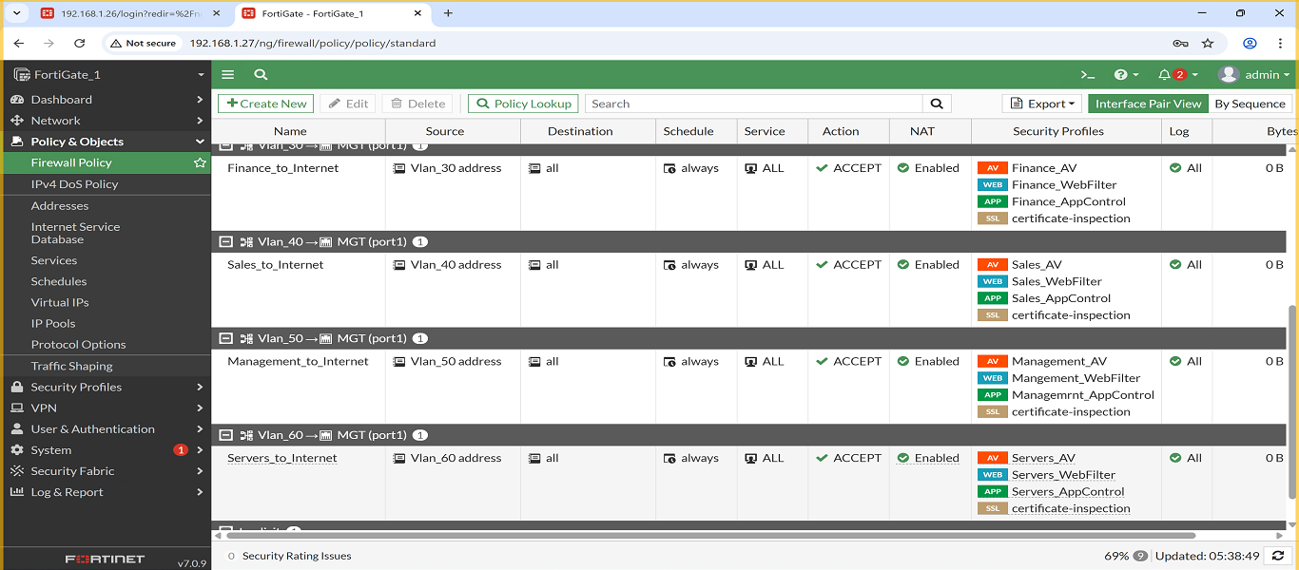
1. Policy: IT → Internet
- Description: Allows IT VLAN access to the internet, and applies the following security profiles: Web Filter, Antivirus and Application Control.
- Screenshot:
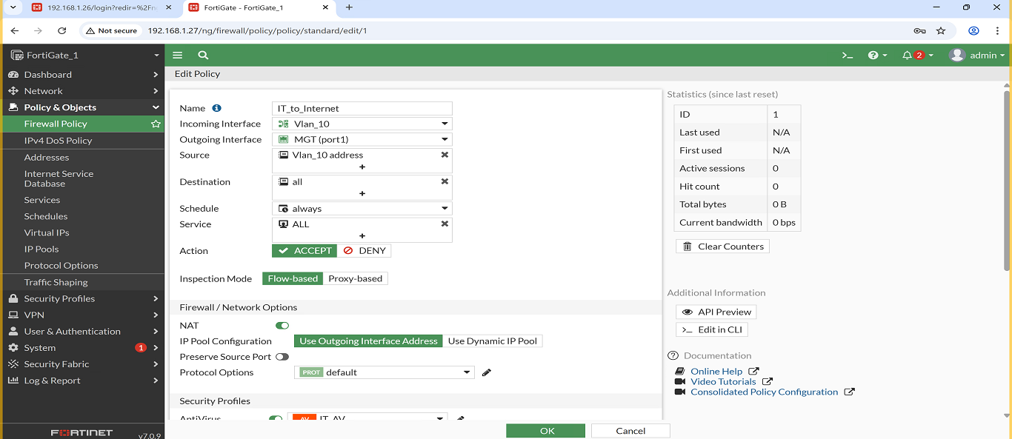
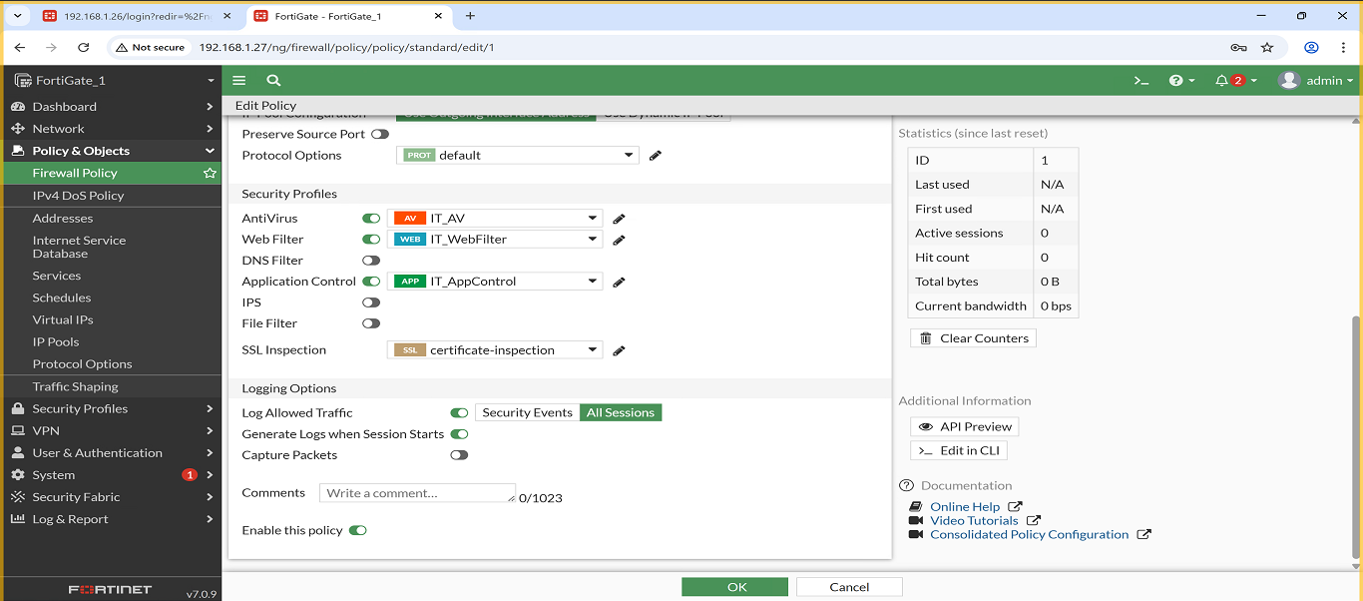

2. Policy: HR → Internet
- Description: Allows HR VLAN access to the internet, and applies the following security profiles: Web Filter, Antivirus and Application Control.
- Screenshot:
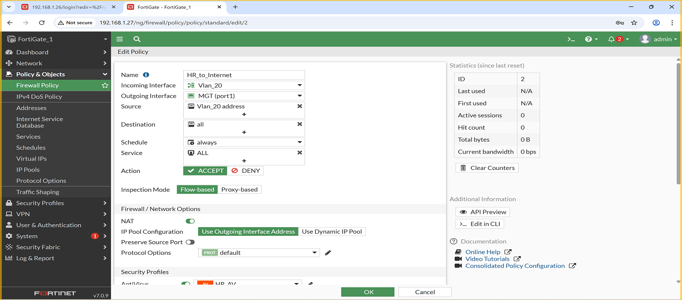
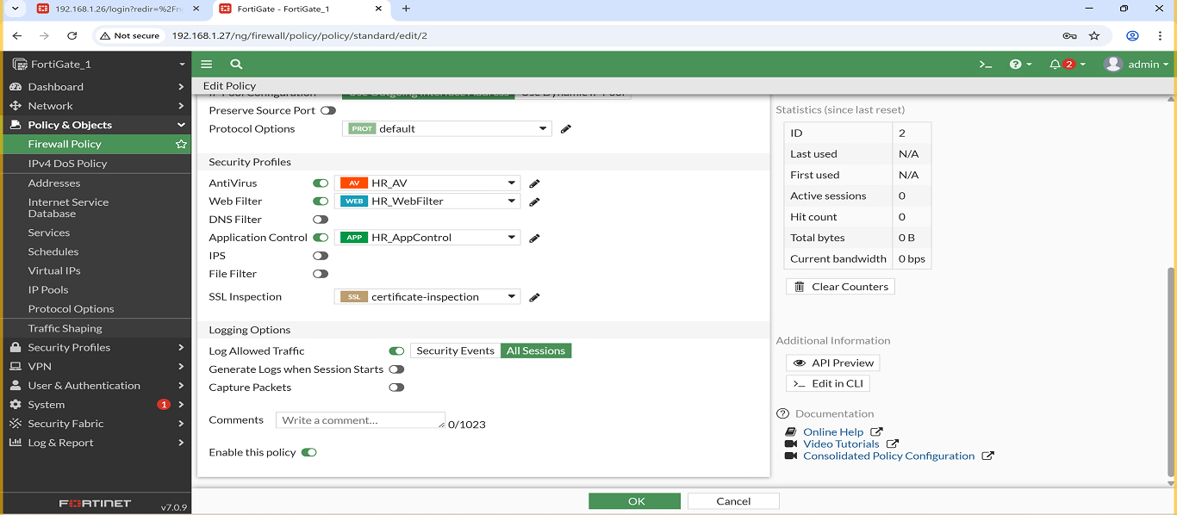

3. Policy: Finance → Internet
Description: Allows Finance VLAN access to the internet, and applies the following security profiles: Web Filter, Antivirus and Application Control.
- Screenshot:
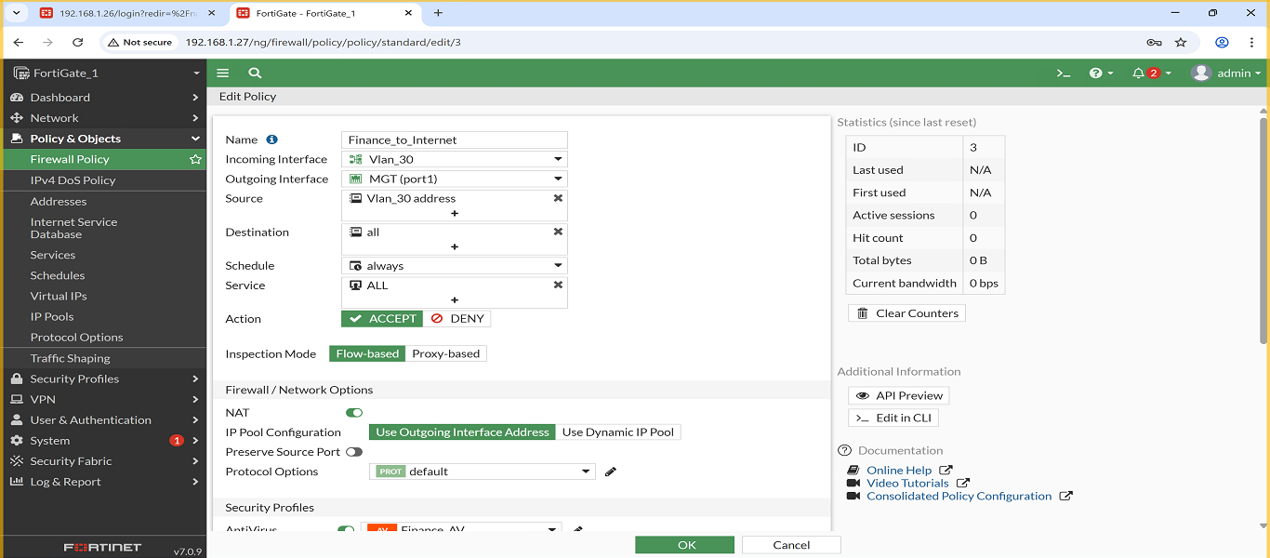
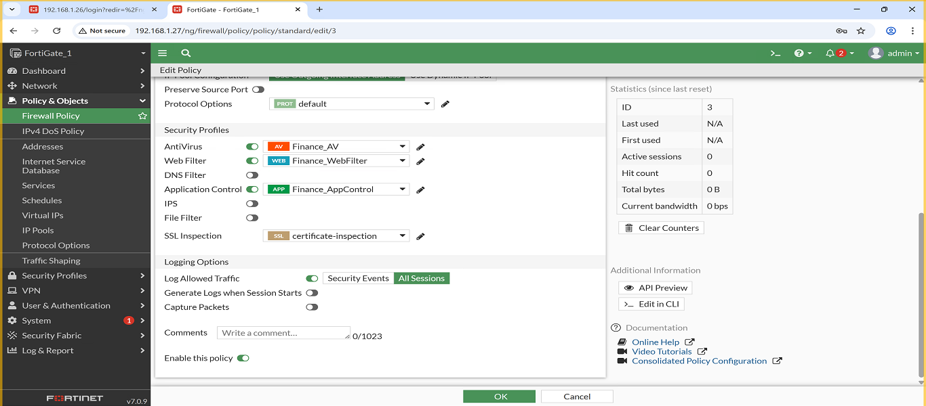

4. Policy: Management → Internet
- Description: Allows Management VLAN access to the internet, and applies the following security profiles: Web Filter, Antivirus and Application Control.
- Screenshot:
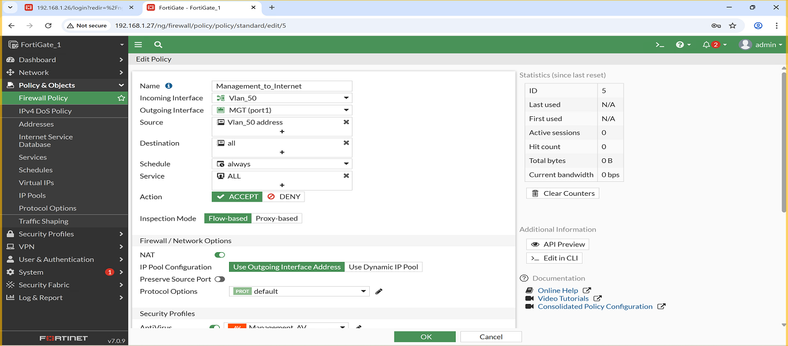
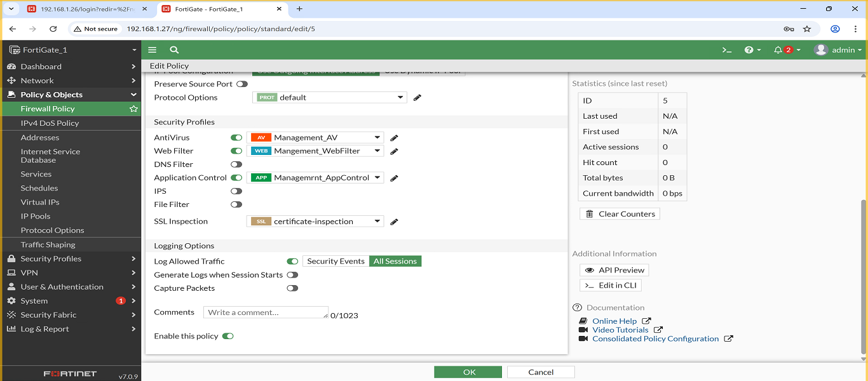
5. Policy: Sales → Internet
- Description: Allows Sales VLAN access to the internet, and applies the following security profiles: Web Filter, Antivirus and Application Control.
- Screenshot:
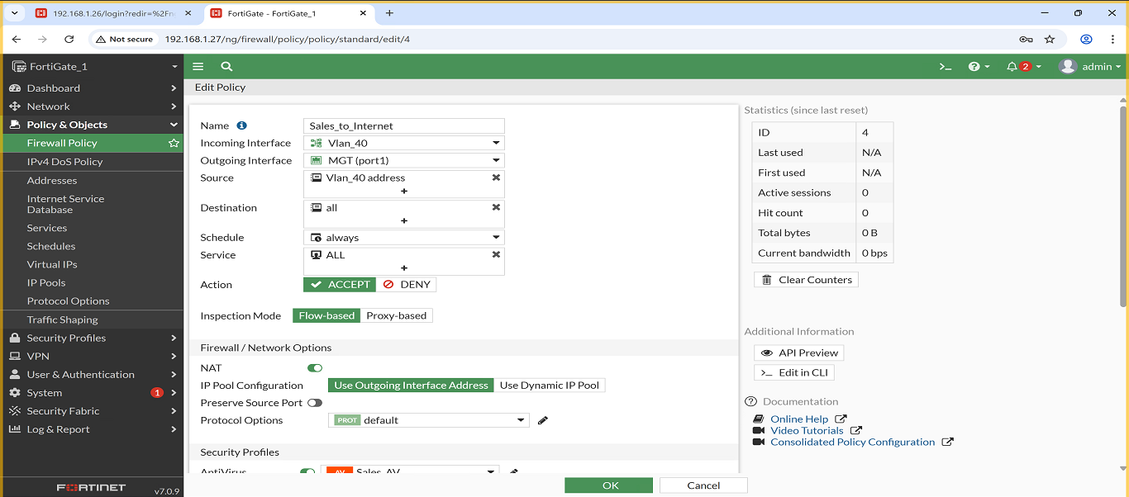
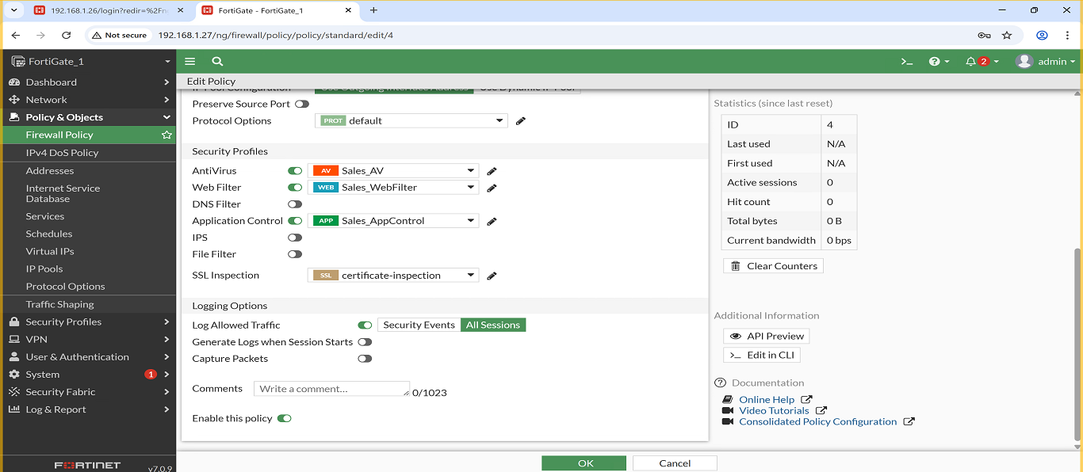
6. Policy: Servers → Internet
- Description: Allows Servers VLAN access to the internet, and applies the following security profiles: Web Filter, Antivirus and Application Control.
- Screenshot:
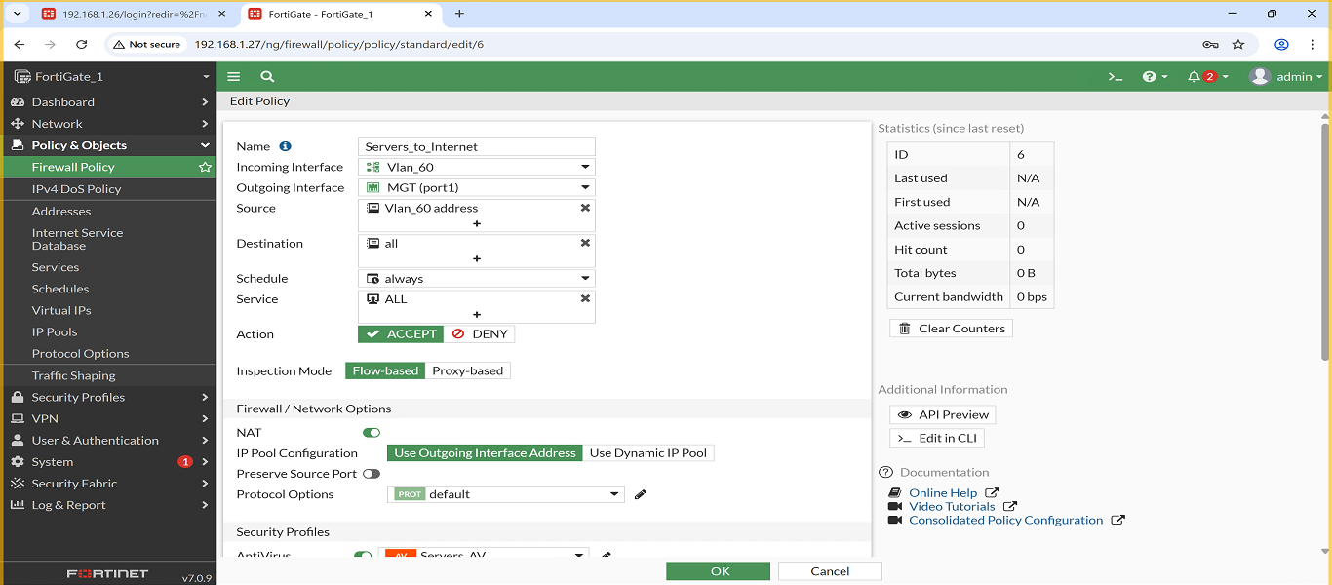
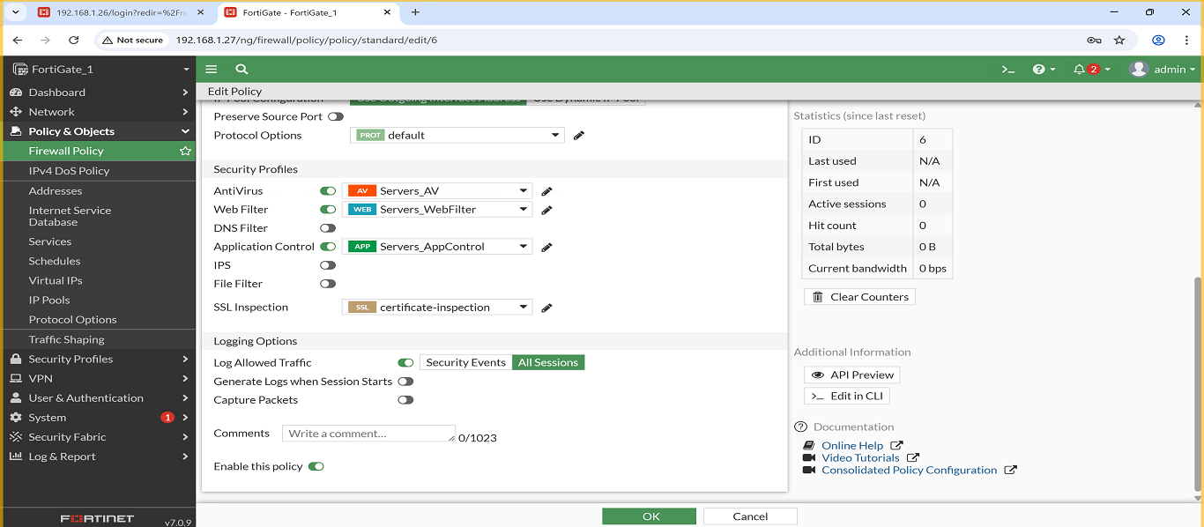
3.3 Security Profiles (BR)
1.Web Filter:
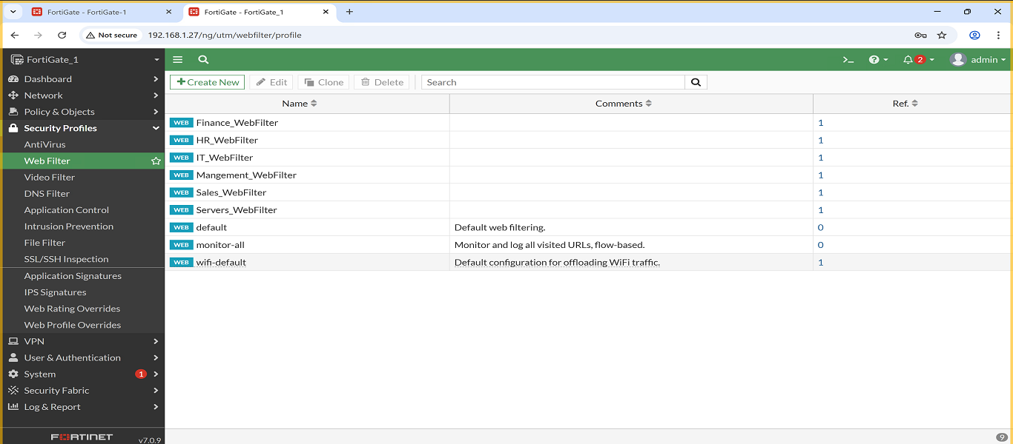

2.AntiVirus:
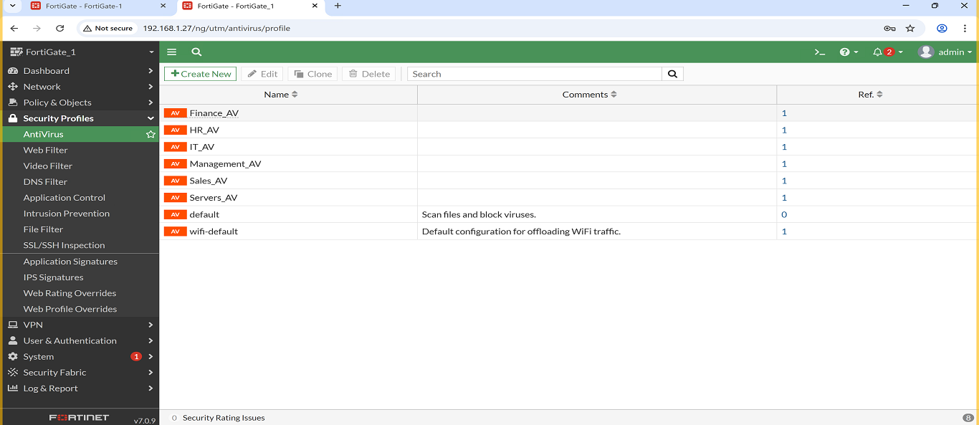
3.Application Control:
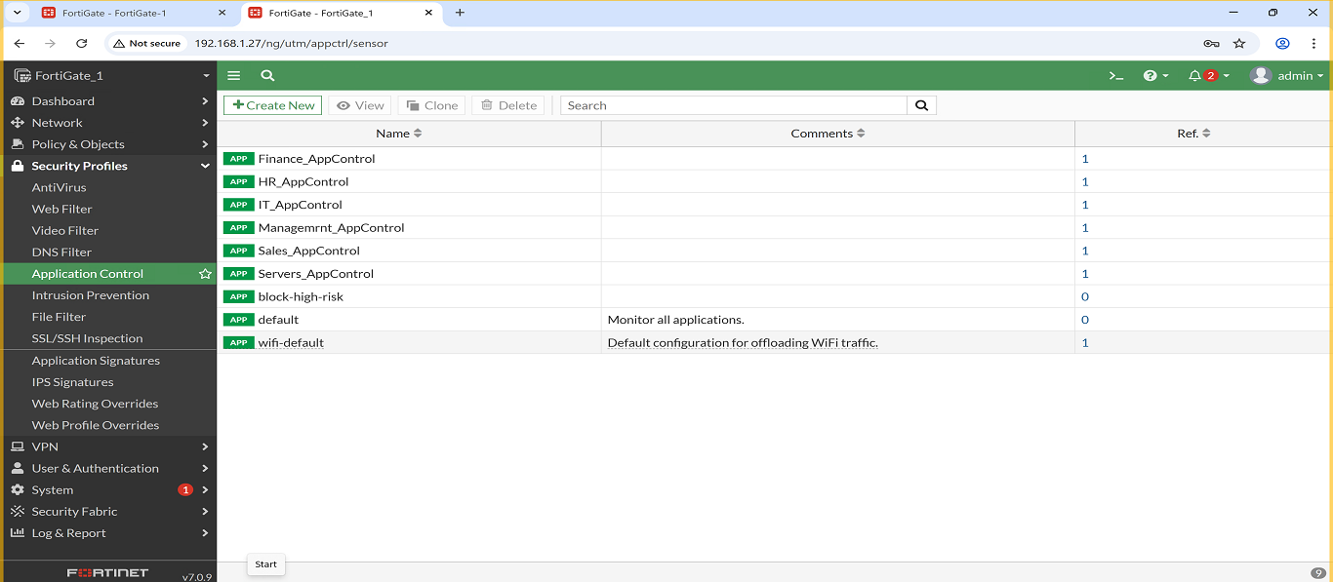

IT VLAN – Security Profiles
Three security profiles were created and assigned to the IT VLAN to enhance security and control user traffic:
- IT_WebFilter
  - Allowed Websites: techcrunch.com , github.com
  - Blocked Websites: facebook.com , youtube.com
  - Screenshot:
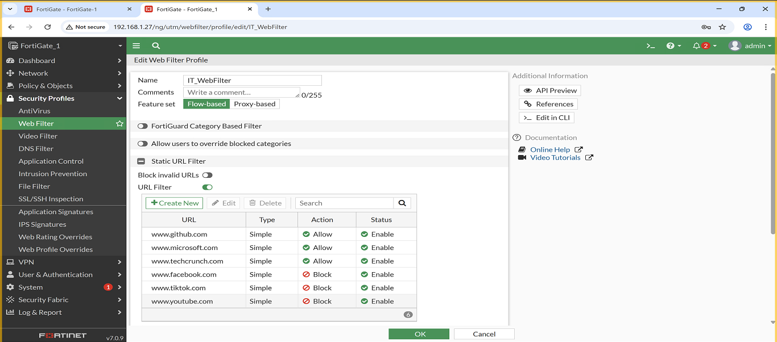

2. IT_Antivirus
  - This AntiVirus profile is configured in Block mode with flow-based scanning, and I enabled inspection for the following protocols: HTTP, SMTP, POP3, IMAP, FTP, and CIFS. Mobile malware protection and Quarantine are also enabled to isolate any detected threats.
  - Screenshot:
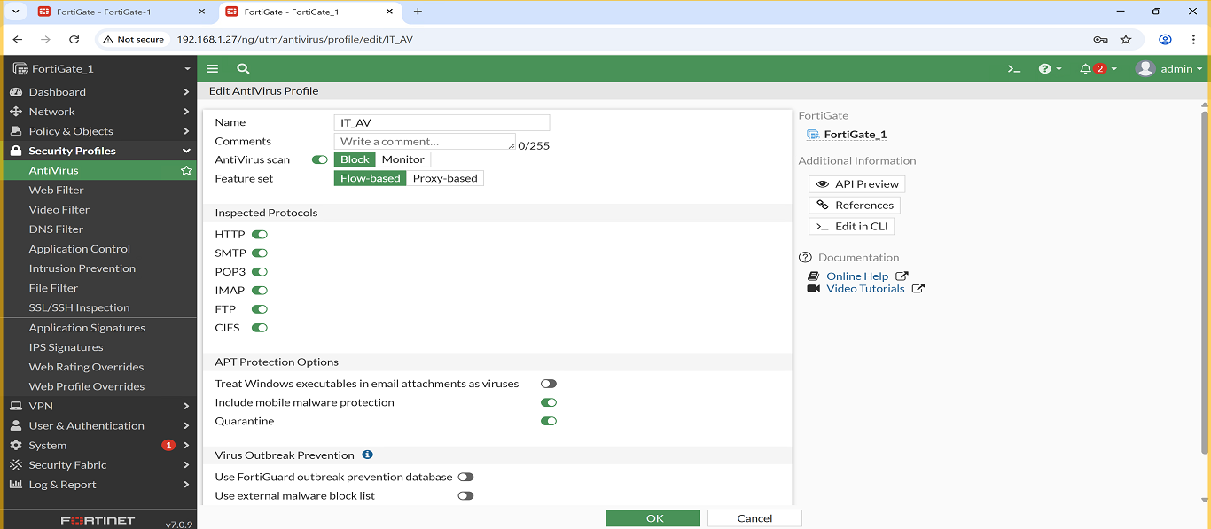
- IT_AppControl
  - I configured rules to allow certain applications and block unnecessary ones, along with custom Application Filters for the IT VLAN to manage traffic.
  - Screenshot:
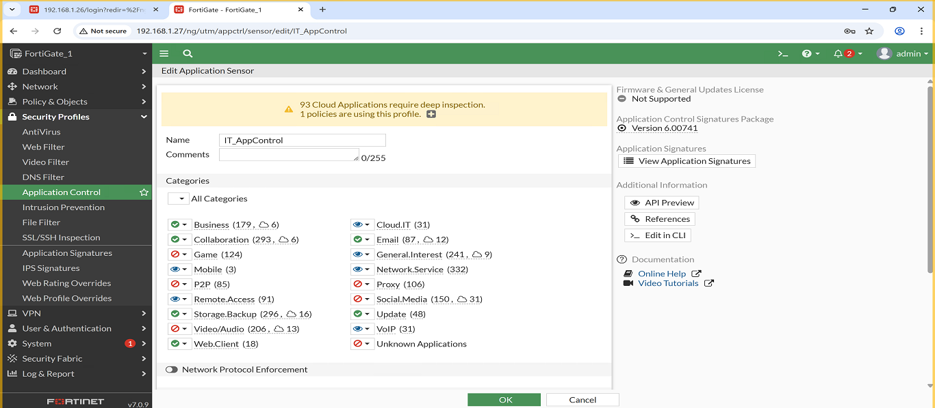
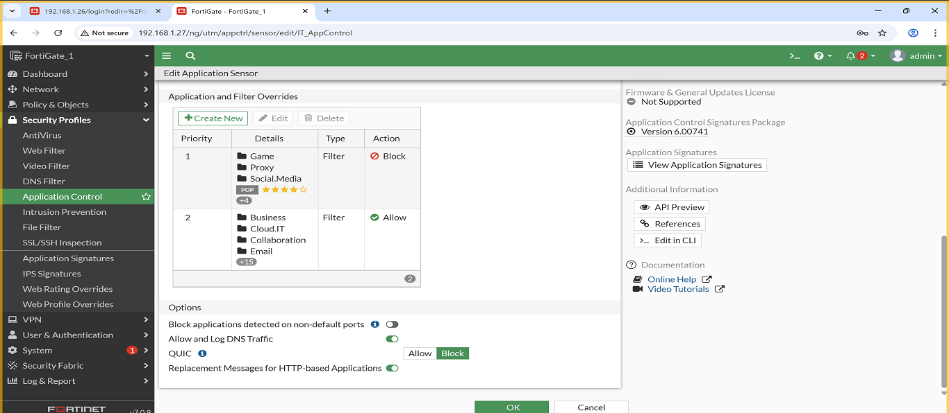

HR VLAN – Security Profiles
Three profiles were applied to ensure HR browsing is monitored and controlled:
- HR_WebFilter
  - Allowed Websites: shopify.com , linkedin.com
  - Blocked Websites: facebook.com , tiktok.com
  - Screenshot:
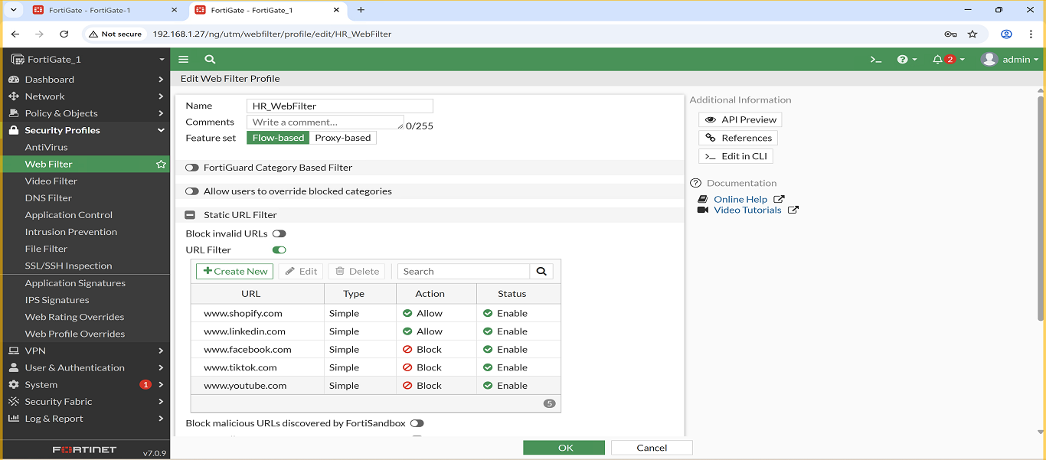
- HR_Antivirus
  - This AntiVirus profile is configured in Block mode with flow-based scanning, and I enabled inspection for the following protocols: HTTP, SMTP, POP3, IMAP, FTP, and CIFS. Mobile malware protection and Quarantine are also enabled to isolate any detected threats.
  - Screenshot:
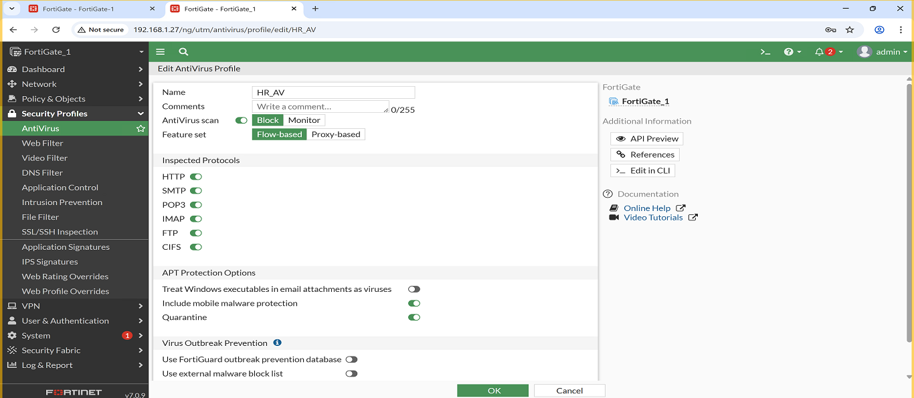
- HR_AppControl
  - I configured rules to allow certain applications and block unnecessary ones, along with custom Application Filters for the HR VLAN to manage traffic.
  - Screenshot:
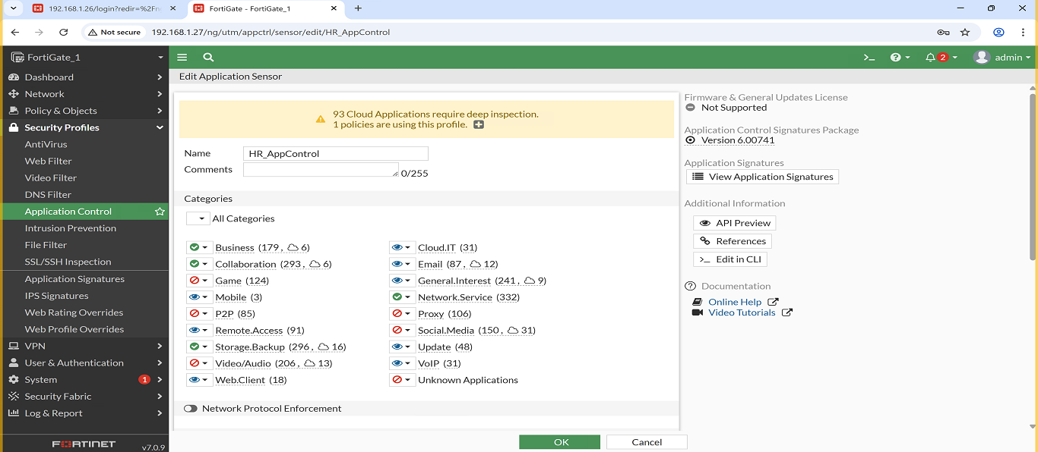
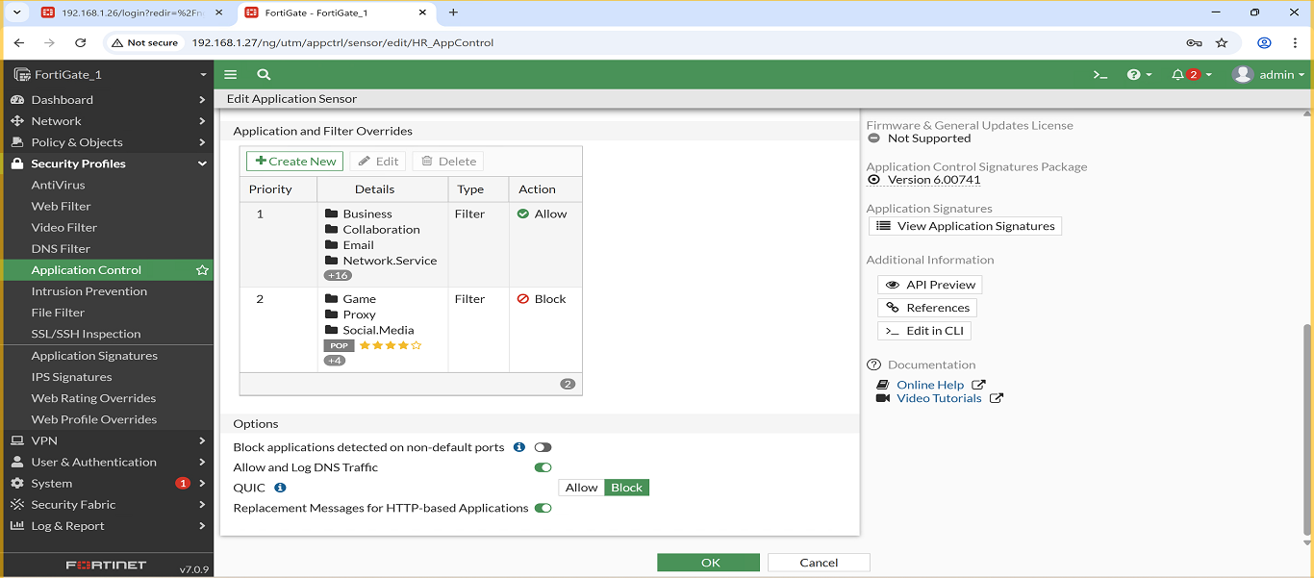

Finance VLAN – Security Profiles
- Finance_WebFilter
  - Allowed Websites: microsoft.com , google.com
  - Blocked Websites: pornhub.com , facebook.com
  - Screenshot:
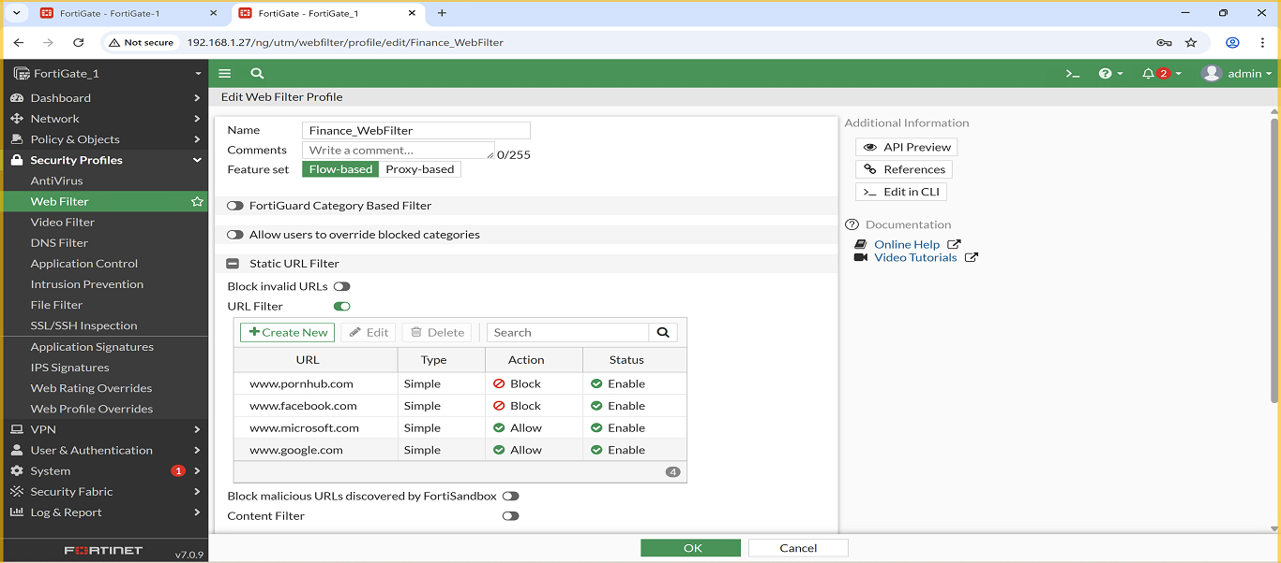
- Finance_Antivirus
  - This AntiVirus profile is configured in Block mode with flow-based scanning, and I enabled inspection for the following protocols: HTTP, SMTP, POP3, IMAP, FTP, and CIFS. Mobile malware protection and Quarantine are also enabled to isolate any detected threats.
  - Screenshot:
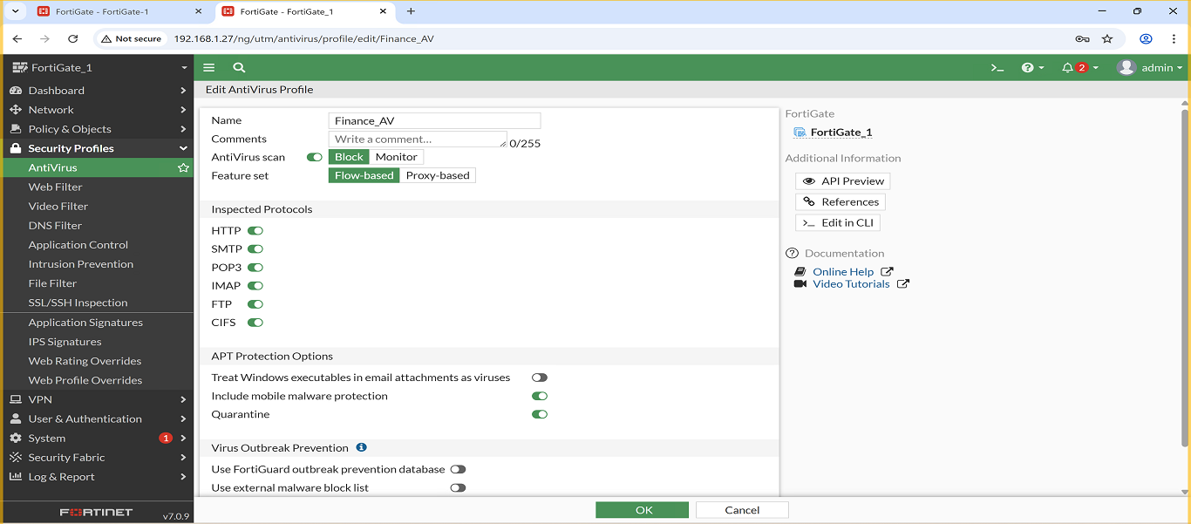
- Finance_AppControl
  - I configured rules to allow certain applications and block unnecessary ones, along with custom Application Filters for the Finance VLAN to manage traffic.
  - Screenshot:
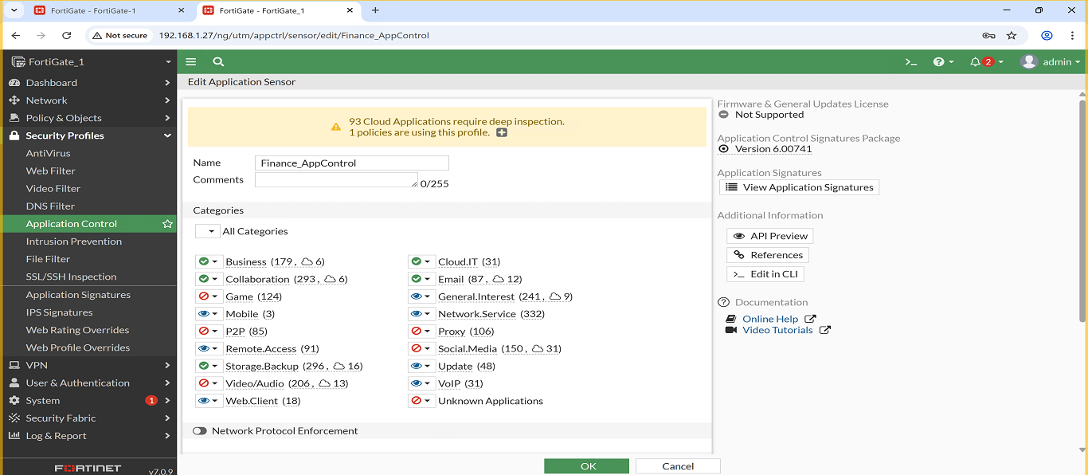
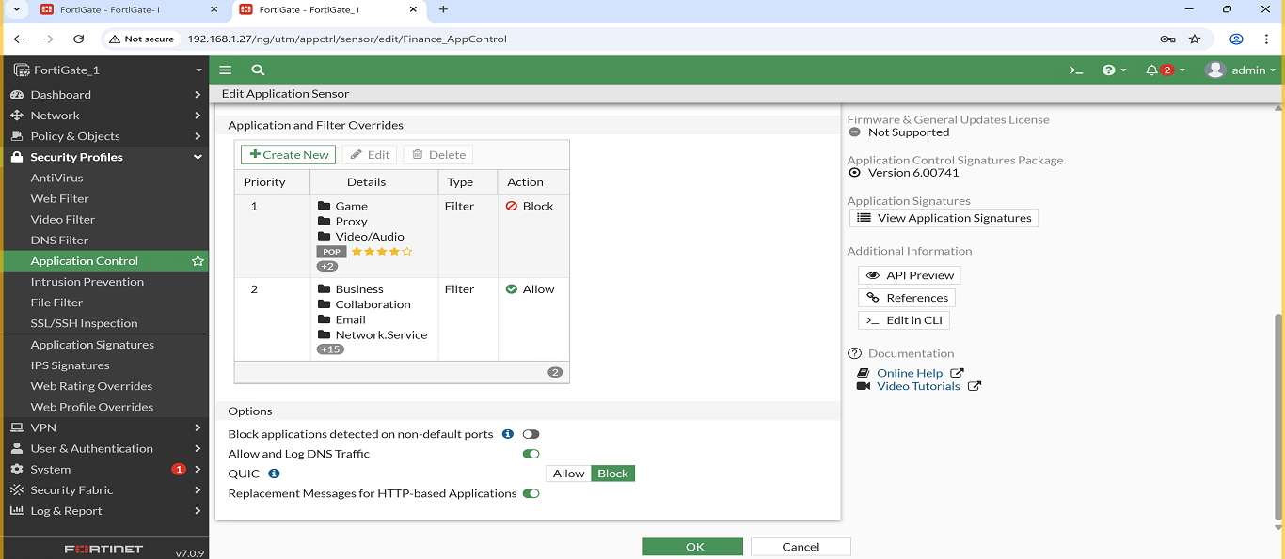

Sales VLAN – Security Profiles
Three security profiles were created and applied to the Sales VLAN to ensure controlled and secure web access:
- Sales_WebFilter
  - Allowed Websites: google.com , microsoft.com
  - Blocked Websites: reddit.com , facebook.com
  - Screenshot:
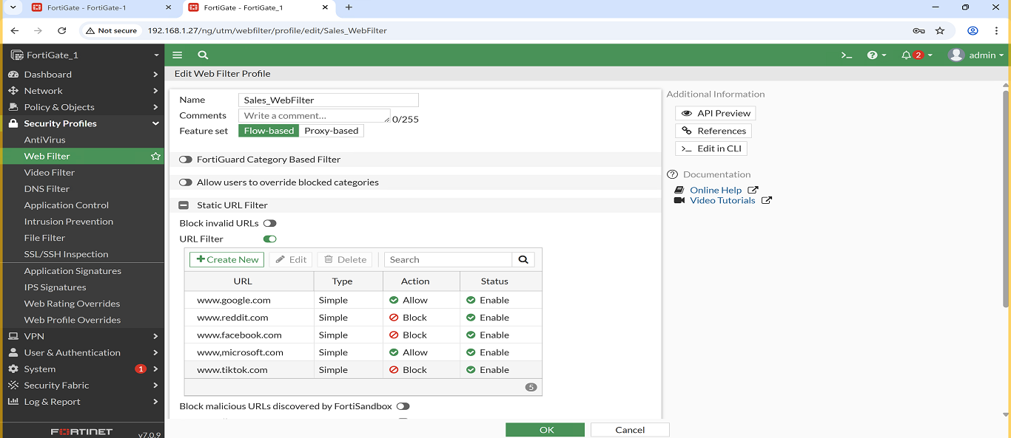
- Sales_Antivirus
  - This AntiVirus profile is configured in Block mode with flow-based scanning, and I enabled inspection for the following protocols: HTTP, SMTP, POP3, IMAP, FTP, and CIFS. Mobile malware protection and Quarantine are also enabled to isolate any detected threats.
  - Screenshot:
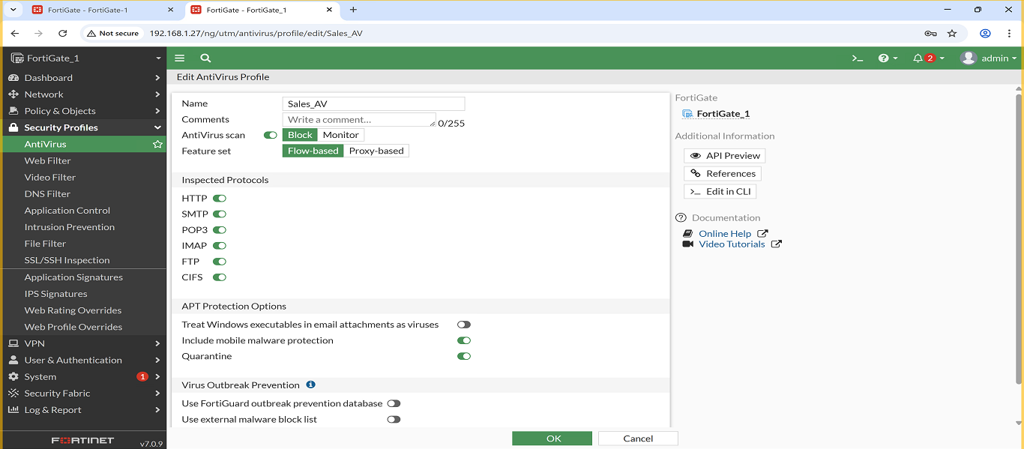
- Sales_AppControl
  - I configured rules to allow certain applications and block unnecessary ones, along with custom Application Filters for the Sales VLAN to manage traffic.
  - Screenshot:
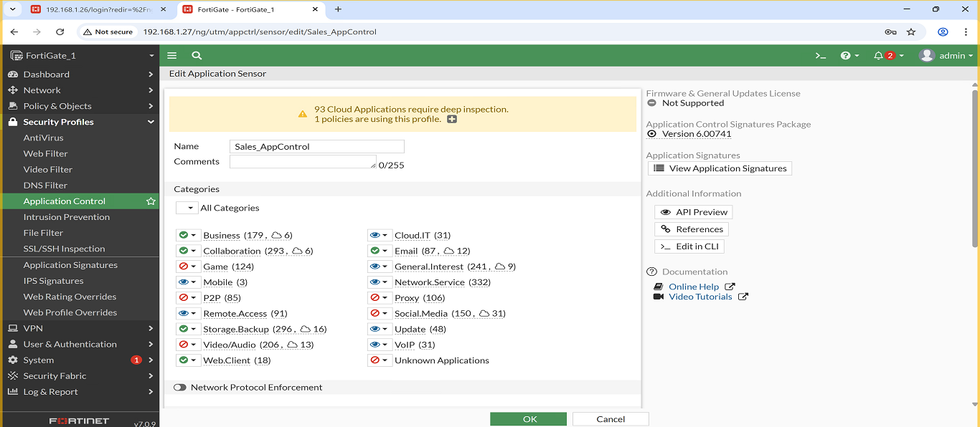
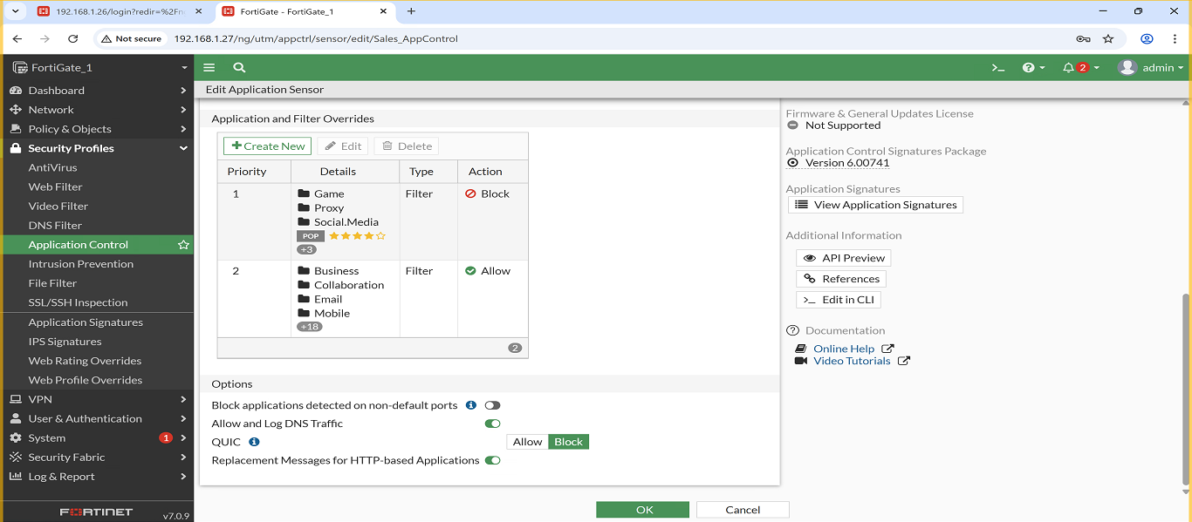

Management VLAN – Security Profiles
Three high-level security profiles were configured for the Management VLAN to ensure safe and controlled access:
- Management_WebFilter
  - Allowed Websites: gmail.com , linkedin.com
  - Blocked Websites: reddit.com , pornhub.com
  - Screenshot:
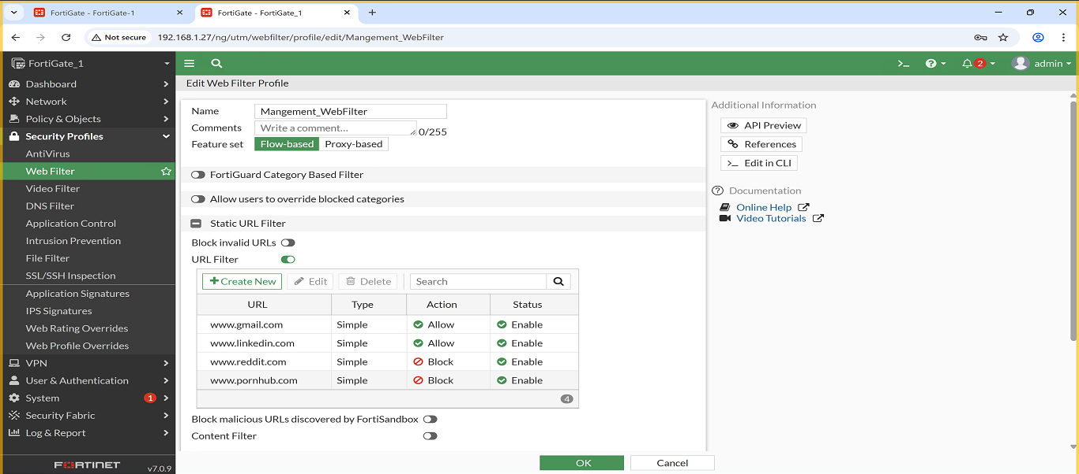
- Management_Antivirus
  - This AntiVirus profile is configured in Block mode with flow-based scanning, and I enabled inspection for the following protocols: HTTP, SMTP, POP3, IMAP, FTP, and CIFS. Mobile malware protection and Quarantine are also enabled to isolate any detected threats.
  - Screenshot:
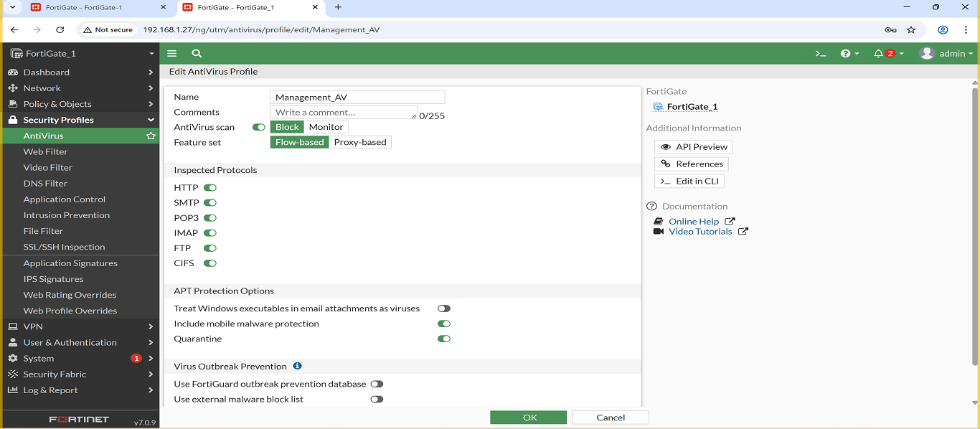
- Management_AppControl
  - I configured rules to allow certain applications and block unnecessary ones, along with custom Application Filters for the Management VLAN to manage traffic.
  - Screenshot:
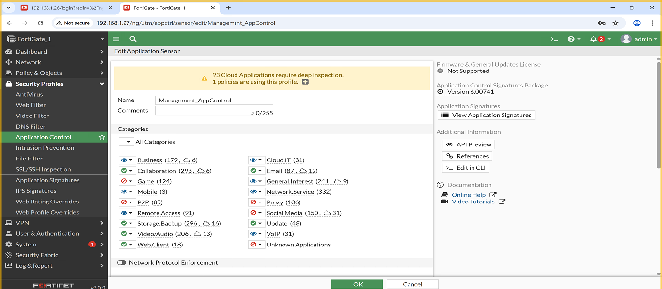
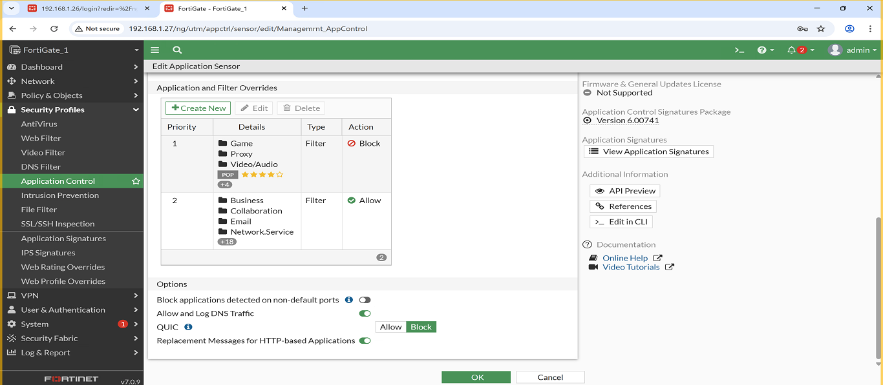

Servers VLAN – Security Profiles
Three security profiles were applied to the Servers VLAN to protect server traffic and maintain stable operations:
- Servers_WebFilter
  - Allowed Websites: google.com , linkedin.com
  - Blocked Websites: facebook.com , youtube.com
  - Screenshot:
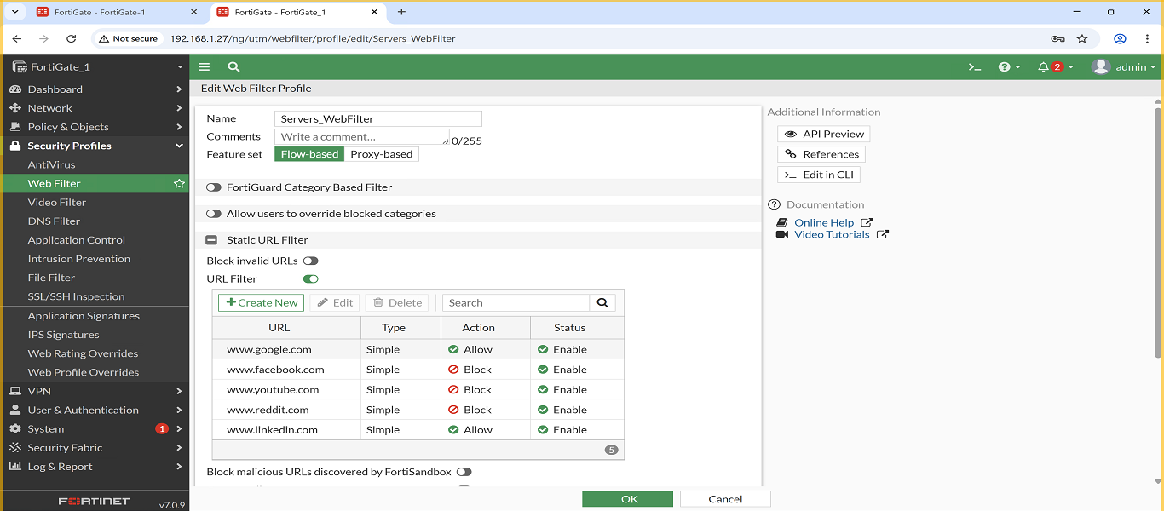
- Servers_Antivirus
  - This AntiVirus profile is configured in Block mode with flow-based scanning, and I enabled inspection for the following protocols: HTTP, SMTP, POP3, IMAP, FTP, and CIFS. Mobile malware protection and Quarantine are also enabled to isolate any detected threats.
  - Screenshot:
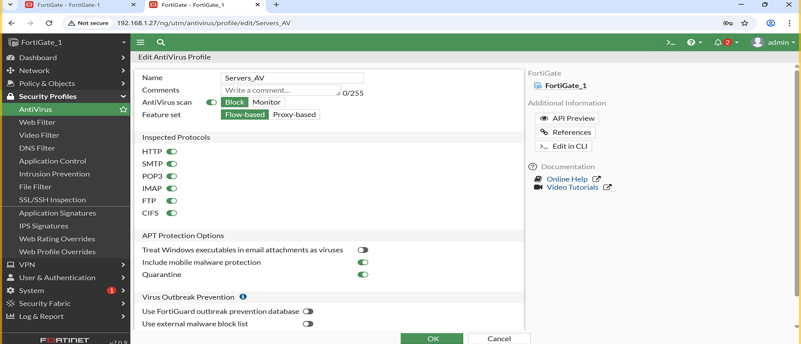
- Servers_AppControl
  - I configured rules to allow certain applications and block unnecessary ones, along with custom Application Filters for the Servers VLAN to manage traffic.
  - Screenshot:
